Master’s in Electronic and Computer Engineering Majoring in Internet of Things.

EEN1058 Assignment

Semester I 2025/26

Kyle Sheehy

21404424

A study of the performance of data transmission in a wireless network environment via modelling and simulations using Network Simulator NS-3.

Declaration

Bit

I hereby declare that, except where otherwise indicated, this document is entirely my own work and has not been submitted in whole or in part to any other university.

Signed: Kyle Adam Sheehy. Date: 25/09/2025

Contents

1. Question A 4

1.1 Part 1 – Calculating Key Performance Metrics 4

1.1.1 Bit Rate and Throughput 4

1.1.2 Delay 5

1.1.3 Average Packet Loss Ratio (PLR) 6

1.2 Part 2 – Key Performance Metrics for Varying Bit Rates (1,5,10,15,20Mbps) 7

1.2.1 Bit Rate and Throughput 7

1.2.2 Delay 8

1.2.3 Packet Loss Ratio (PLR) 10

2. Question B – Key Performance Metrics vs Distance 11

2.1 Introduction 11

2.2 Initial Simulation and Observed Limitations 11

2.3 Adjusting Transmission Power 13

2.4 Receiver Sensitivity and Bit Rate Adjustment 15

2.5 Distance vs Throughput 15

2.6 Distance vs Delay 16

2.7 Distance vs PLR 17

3. Question C 18

3.1 Introduction 18

3.2 Wi-Fi 6 (IEEE802.11ax) 18

3.3 Wi-Fi 7 (IEEE802.11be) 18

3.4 Distance vs Throughput vs User Count 19

3.5 Distance vs Delay vs User Count 22

3.6 Distance vs PLR vs User Count 24

4. Comparison and Analysis 25

4.1 Question A 25

4.1.1 Bit Rate vs Throughput 25

4.1.2 Bit Rate vs Delay 28

4.1.3 Bit Rate vs PLR 28

4.1.4 Overall Trends 29

4.2 Question B 29

4.2.1 Distance vs Throughput 29

4.2.2 Distance vs Delay 30

4.2.3 Distance vs PLR 30

4.2.4 Overall Trends 30

4.3 Question C 31

4.3.1 Literature 31

4.3.2 Throughput vs Distance vs User Count 31

4.3.3 Delay vs Distance vs User Count 32

4.3.4 PLR vs Distance vs User Count 33

4.3.5 Overall Trends with respect to the Literature 34

5. References 35

6. Appendix A – Files 35

6.1 Question A 35

6.1.1 Part 1 35

6.1.2 Part 2 35

6.2 Question B 36

6.2.1 Original Sim 36

6.2.2 Altered Sim 37

6.3 Question C 37

6.3.1Wi-Fi 6 37

6.3.2 Wi-Fi 7 38

7. Appendix B – Images 39

7.1 Question A 39

7.1.1 Part 1 40

7.1.2 Part 2 40

7.2 Question B 40

7.2.1 Original Sim 40

7.2.2 Altered Sim 40

7.3 Question C 41

7.4 Comparison 41

7.4.1 Question A 41

# Question A

## 1.1 Part 1 – Calculating Key Performance Metrics

### 1.1.1 Bit Rate and Throughput

In the original simulation, the transmission rate was determined to be 160Kbps. This value represents the rate at which data was transmitted during the simulation and is calculated by:

$$Bit Rate (bps)= \frac{Total bits Tx}{Simulation Time}$$

The total number of bits transmitted is obtained from the number of transmitted packets multiplied by the packet size and converted from bytes to bits:

$$Total bits Tx= Total Tx Packets*Packet Size*8$$

The conversion factor of 8 is applied to change bytes into bits. To express the result in kilobits per second (Kbps), the rate is divided by 1000. This calculation is implemented in line 120 of QuestionA-Part1.py.

Similarly, throughput measures rate of successfully received data and is calculated as:

$$Throughput (bps)= \frac{Total bits Rx}{Simulation Time}$$

$$Total bits Rx= Total Packets Rx*Packet Size*8$$

Both metrics were computed and subsequently plotted to compare transmission rate and effective data delivery. The throughput vs bitrate relationship provides insight into the channel efficiency, which indicates how effectively the bandwidth is being utilised. Efficiency can be expressed as a ratio of throughput to bit rate, where 100% indicates a perfectly effective channel (lossless).

Figure 1 illustrates this relationship, showing how throughput tracks the bit rate and highlighting any loss due to network delays, interference, or retransmissions.

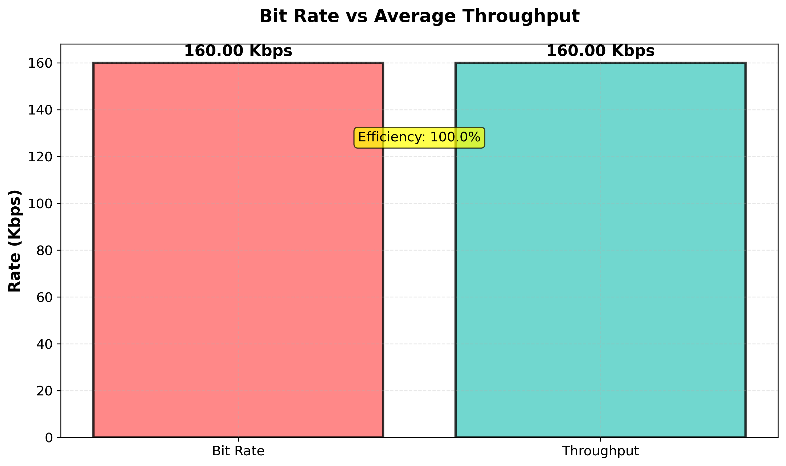

*Figure 1 – plot of Bit Rate and throughput in Kbps. Efficiency is overlayed on the figure to indicate that at this transmission rate, the throughput is equal to the bit rate which implies a loss less channel.*

Figure 1 graphically represents the analysis of Bit Rate and Throughput, with efficiency highlighting their relationship. As the throughput is equal to the Bit Rate, there is no loss experienced in this scenario. This is not representative of a real-world channel, where there are multiple losses across the channel – even at relatively short distances (50m in this simulation).

### 1.1.2 Delay

One of the key performance metrics recorded in the scalar output files is packet delay, which represents the time taken for a packet to travel from the sender to the receiver. The .sca file provides three delay values – minimum, maximum and average delay – measured in nanoseconds.

To express these values in seconds, each value was divided by 1x109. This conversion was applied before plotting the results. All three delay metrics were plotted on the same graph to visualise the variation in delay and to identify potential outliers, as illustrated by figure 2 below.

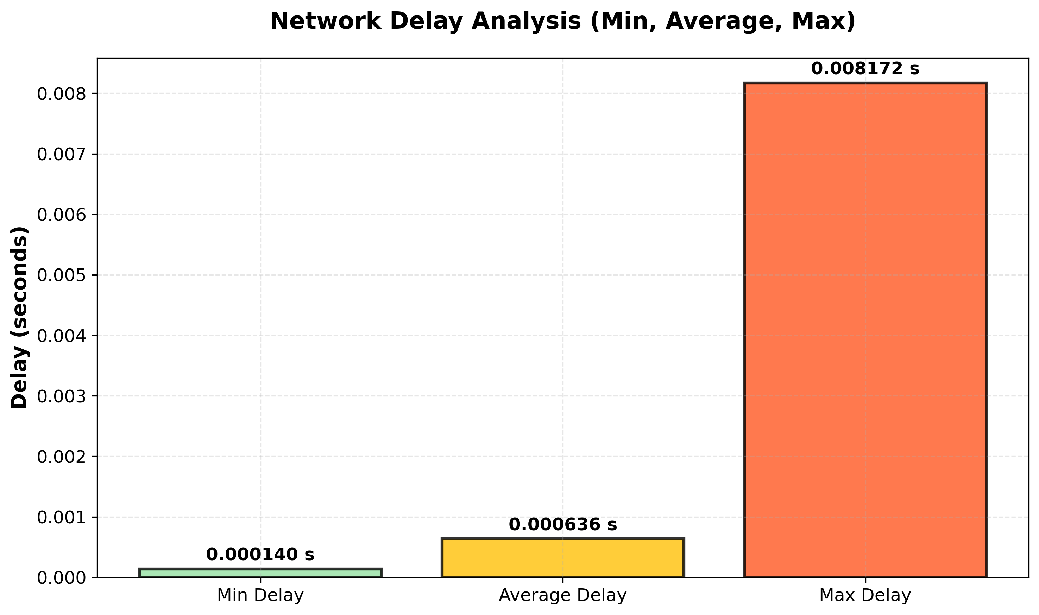

*Figure 2 – Delay statistics as parsed from the .sca file and converted from nanoseconds to seconds.*

From figure 2, it can be observed that the average delay for this simulation was approximately 0.000636 seconds (0.636 milliseconds). This value indicates that the network performance is relatively stable, with minimal latency variation between packets. The maximum delay value represents a rare instance of increased transmission time, potentially caused by queuing or temporary interference simulated.

### 1.1.3 Average Packet Loss Ratio (PLR)

The Packet Loss Ratio (PLR) quantifies the proportion of data packets that fail to reach the receiver during transmission. It provides an indication of the reliability of the communication channel. PLR is calculated by the following:

$$PLR= \frac{Tx packets-Rx packets}{Tx Packets}$$

This ratio represents the fraction of lost packets relative to the total number of transmitted packets and is often expressed as a percentage (not in this example).

For this simulation, the bit rate and throughput were equal, indicating that all transmitted packets were received successfully. Consequently, the PLR is effectively 0, signifying an error-free transmission under this simulation’s circumstances.

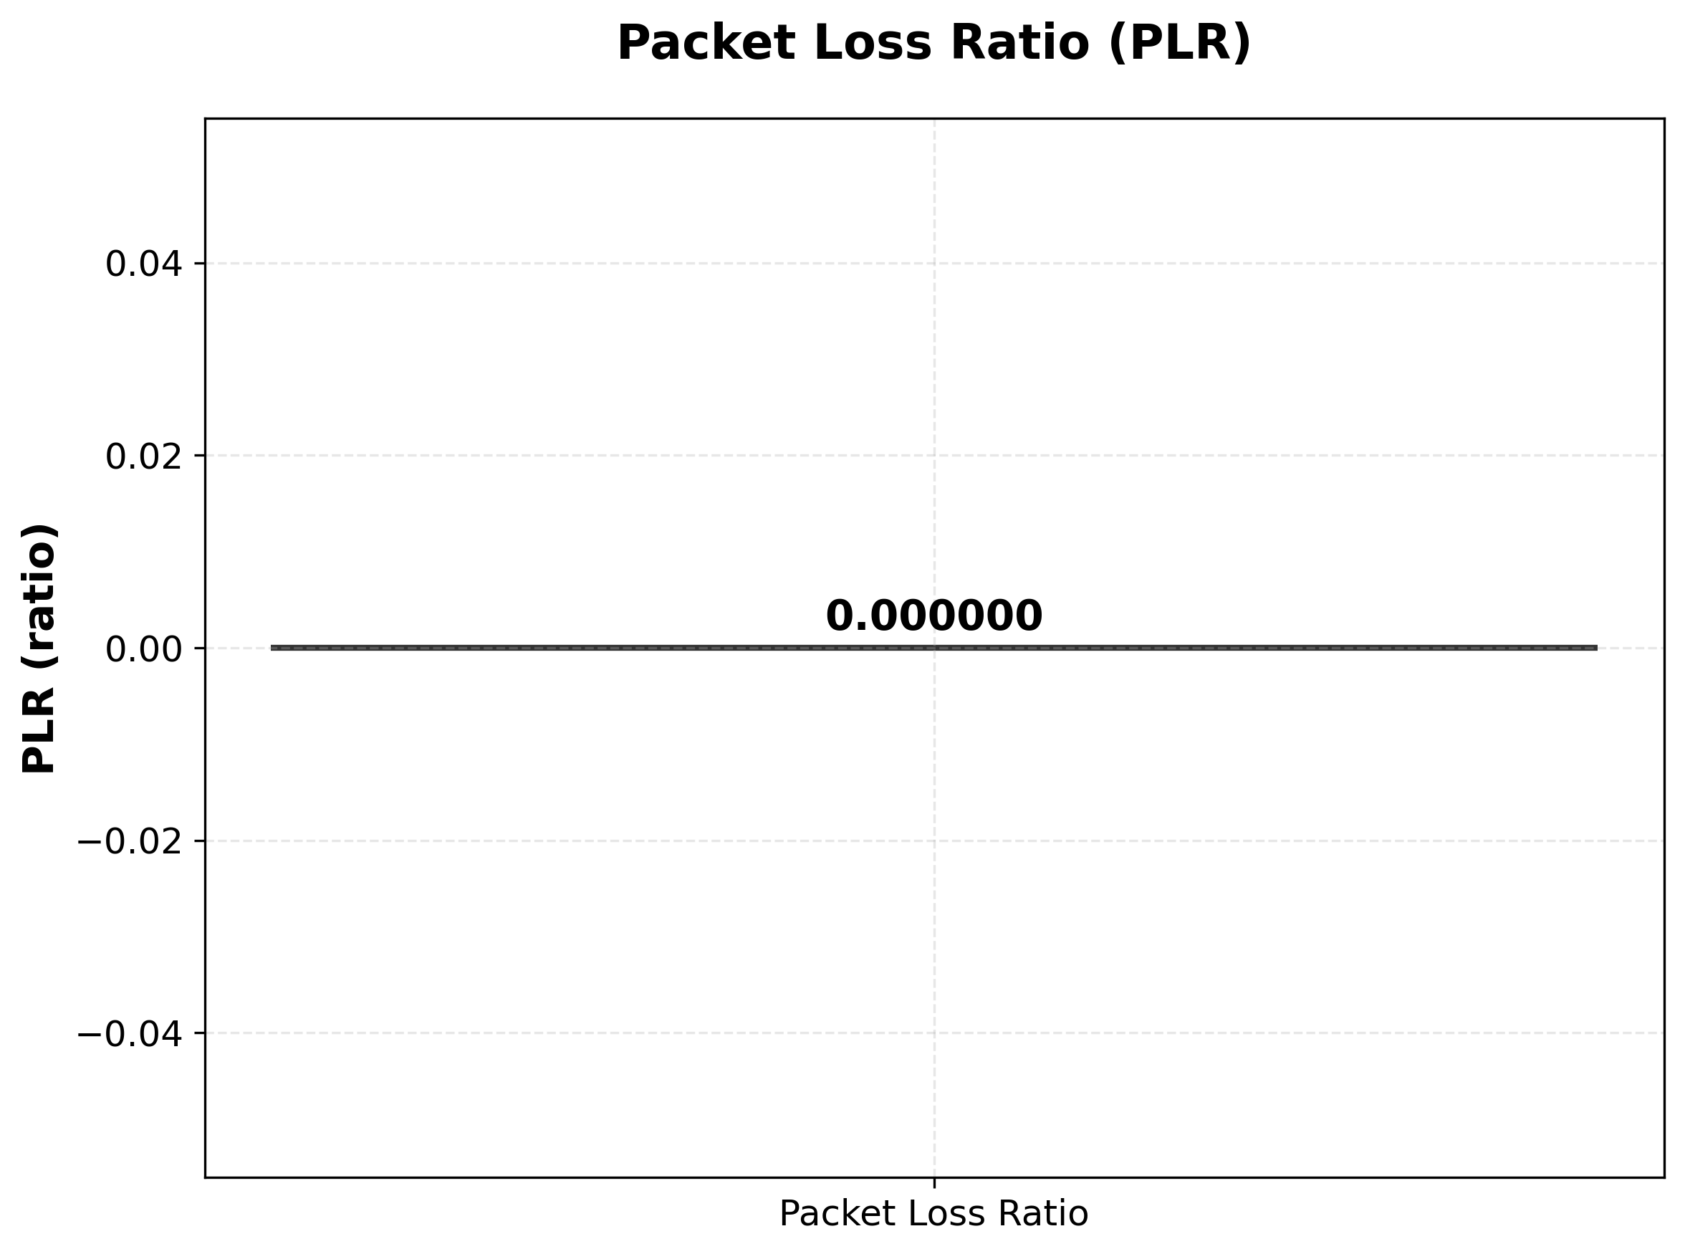

*Figure 3 – Calculated PLR for the simulation*

As the efficiency is 100%, it can be concluded that the PLR is 0%. The calculation visualised in figure 3 confirms this conclusion.

## 1.2 Part 2 – Key Performance Metrics for Varying Bit Rates (1,5,10,15,20Mbps)

This section investigates how varying the configured transmission bit rate affects key performance metrics such as throughput, delay, and packet loss ratio. Each simulation was executed at a distinct bit rate – 1, 5, 10, 15, 20 Mbps – and the resulting scalar files were stored in dedicated folders for post-processing and analysis – see Appendix A for file management details.

To maintain clarity, the source file wifi-example-sim-updated.cc was modified to automatically append the configured bit rate to the output file name. For instance, the first simulation (1Mbps) generated the file “DataOfUser1-1759410141-1000kbps-.sca”, where the suffix reflects the active bit configuration. This ensured clear traceability between simulation parameters and results. As the simulation can be altered from command line arguments, if there is a change made, the parameter is appended to the name as shown above.

### 1.2.1 Bit Rate and Throughput

In theory, throughput represents the effective data successfully received per unit time, while bit rate indicates the raw rate of data transmission configured in the system. Although these two parameters are closely related, they diverge as channel conditions and network congestion introduce inefficiencies.

As the bit rate increases, the throughput tends to decrease. This occurs because transmitting more data per second can exceed the network’s capacity to handle packets efficiently, leading to queuing, retransmissions, or packet drops. For example, as packets are forwarded from node A to node B, node B must process each packet header before routing it onward. When transmission rates increase, node B’s buffer may become saturated, causing some packets to be dropped. These dropped packets must be retransmitted, effectively reducing the overall throughput.

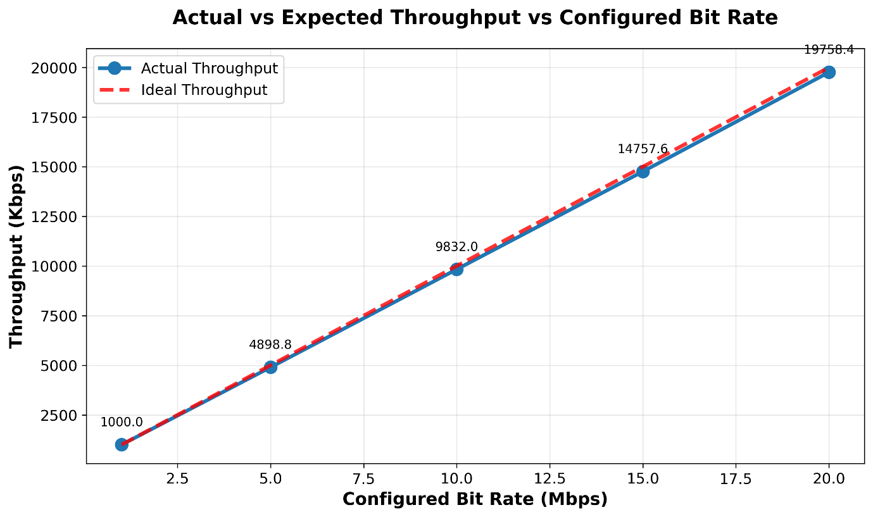

*Figure 4 – Relationship between configured bit rate (Mbps) and calculated throughput (Kbps). The dashed red line represents the ideal throughput – a theoretical case assuming 100% efficiency and no packet loss. The solid blue line shows the calculated actual throughput.*

At lower bit rates (below approximately 2.5Mbps), the two lines closely overlap, indicating near-perfect channel efficiency. However, as bit rate increases, the actual throughput diverges progressively from the ideal line. This widening gap signifies increased packet loss and reduced efficiency at higher transmission rates. The results therefore confirm the expected inverse relationship between configured bit rate and achieved throughput under fixed network conditions.

### 1.2.2 Delay

As discussed previously, increasing the configured bit rate results in reduced throughput, which generally implies a corresponding increase in network delay. For clarity, delay values have been expressed in milliseconds (ms) rather than seconds.

As the bit rate increases, network congestion becomes more significant, leading to higher queuing and processing times. However, it is important to note that delay does not increase in a strictly predictable or linear manner. This is because the channel conditions are inherently variable, and the simulator accurately reflects this randomness in packet transmission and scheduling.

In networking, the total delay experienced by a packet is composed of four main components:

$${Delay}_{Total}= {Delay}_{Transmission}+{Delay}_{Propagation} +{Delay}_{Queuing} +{Delay}_{Processing}$$

Transmission delay is the time taken to get the packets onto the network. It is dependent on the packet size and bandwidth. Both of which are fixed in this example.

Propagation delay is how long it takes the signal to travel the medium, which is influenced by distance and signal speed, which are also fixed for example.

Queuing delay is the wait time for data packets in the device’s buffer. It is influenced by packet volume and network congestion – both affected by increased bit rate.

Processing delay is the time network devices use to check packet headers and make routing decisions, which increases with respect to increased configured bit rate.

Figure 5 shows the relationship between average delay and configured bit rate.

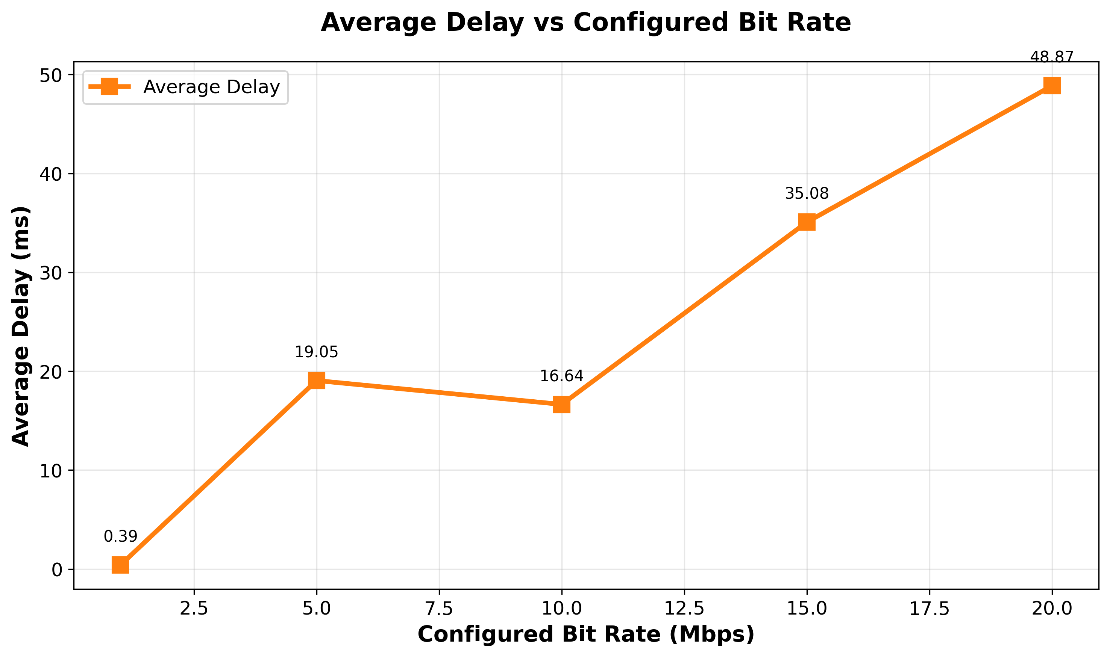

*Figure 5 – Average Delay versus Configured Bit Rate (Mbps). The delay is calculated in the wifi-example-sim-updated.cc file.*

From figure 5, it can be observed that delay generally increases with higher bit rates. An anomaly occurs at 5Mbps where the delay is higher than at 10Mbps. This deviation is most likely caused by a significant outlier in the 5Mbps dataset rather than the anomaly lying in the 10Mbps data. A linear regression analysis (e.g., by calculating the R2 value) could further validate this observation, though a simple visual inspection already supports the conclusion that delay increases approximately proportionally with bit rate.

### 1.2.3 Packet Loss Ratio (PLR)

The PLR quantifies the proportion of data packets that fail to reach their destination during transmission, providing an indicator of overall channel reliability. As observed in previous sections, a decrease in throughput typically suggests an increase in PLR. However, the relationship between configured bit rate and packet loss in this simulation is non-linear and non-predictable.

Analysis of the PLR results revealed that increased delay does not necessarily correspond to higher packet loss, indicating that delay and packet loss are not directly proportional. While it might be expected that PLR would rise steadily with higher bit rates due to congestion, the results instead show a slight decline (≈0.4%) between 10Mbps and 20Mbps. This unexpected trend suggests variability in network conditions and reinforces the stochastic nature of wireless channels modelled in the simulator.

A noticeable spike in PLR occurs at 5Mbps, aligning with the anomaly identified in the delay analysis. This outlier likely indicates a fault or unusual event during that simulation run such as transient congestion or a buffer overflow. Despite this, the findings demonstrate that the simulator effectively reproduces the random and unpredictable characteristics of real-world wireless communication channels.

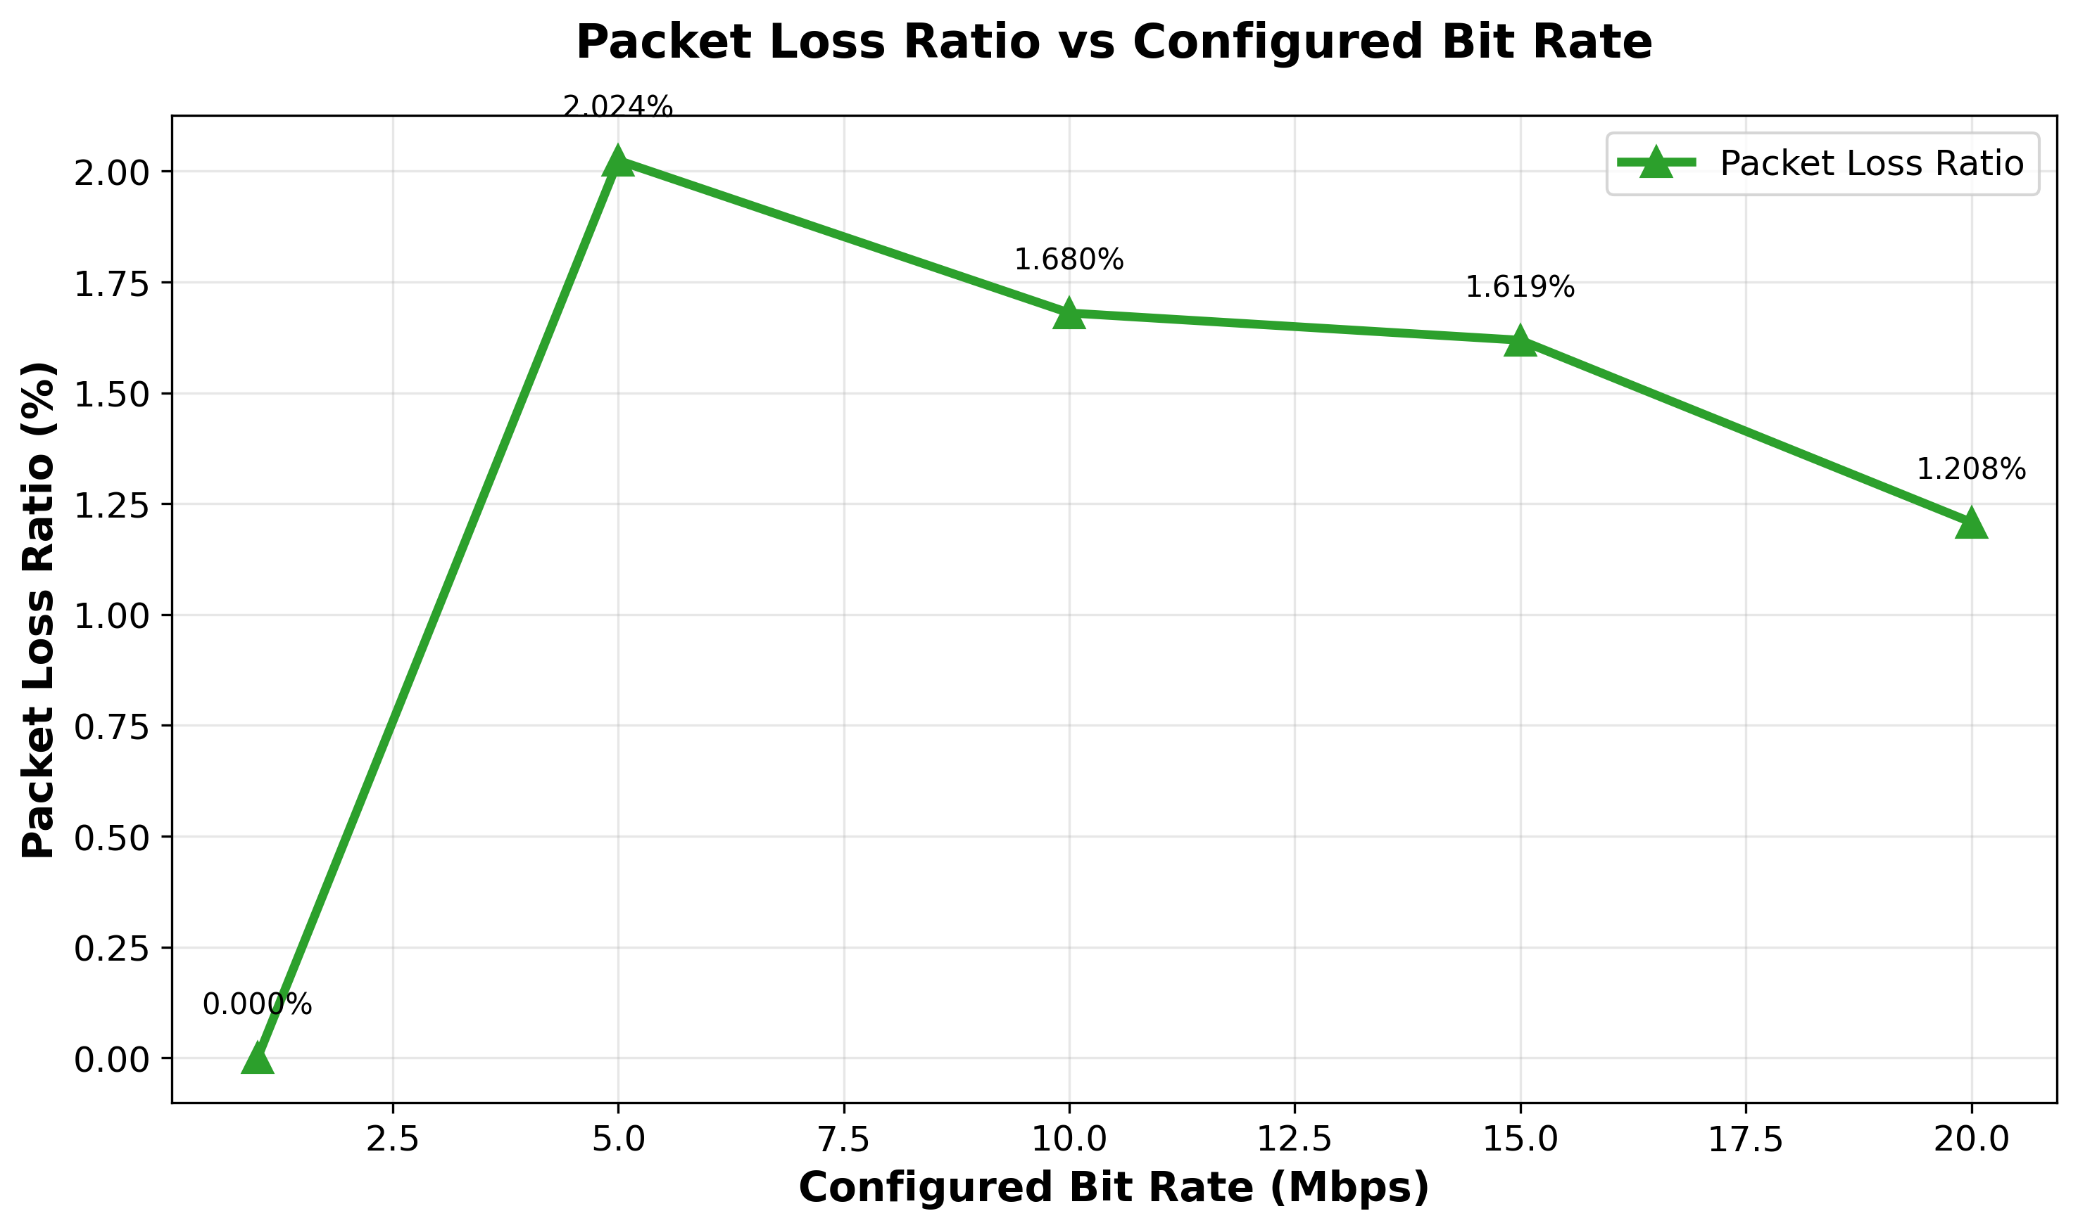

*Figure 6 – Calculated PLR vs Configured Bit Rate (Mbps)*

From figure 6, the PLR is 0% for 1Mbps which coincides with the conclusions drawn in the throughput section where ideal and actual were overlapping at low bit rates. The isolated spike at 5Mbps indicates a temporary increase in dropped packets, likely due to buffer overflow or processing delays.

Overall, while PLR would theoretically increase linearly with bit rate under sustained congestion, the simulation results suggest otherwise – possibly due to the relatively low data rates used (max 20 Mbps). In modern systems, bit rates can reach 20Gbps [1], roughly 1000 times greater than those used here, which would amplify the effects of congestion and packet loss.

# Question B – Key Performance Metrics vs Distance

## 2.1 Introduction

The objective of Question B is to evaluate the performance of the Wi-Fi system when the distance between the access point (AP) and the user is increased, while keeping the bit rate fixed. This investigation extends the analysis from Question A by studying how throughput, delay, and PLR vary with distance.

## 2.2 Initial Simulation and Observed Limitations

The initial simulation was configured using the default parameters from wifi-example-sim-updated.cc, with a fixed transmission rate of 160Kbps, and the default distance between the user and AP of 50m. When the distance parameter was extended beyond 50m, the simulation results showed the following:

* Throughput = 0Kbps (no data successfully received)
* Delay = 0 s
* PLR = 100%

These outcomes, illustrated in figures 7-9, indicate that the signal strength was insufficient for communicating beyond 50m. The loss of throughput and corresponding rise is PLR confirmed that packets were not reaching the receiver, while a delay of zero implied a complete loss of connection.

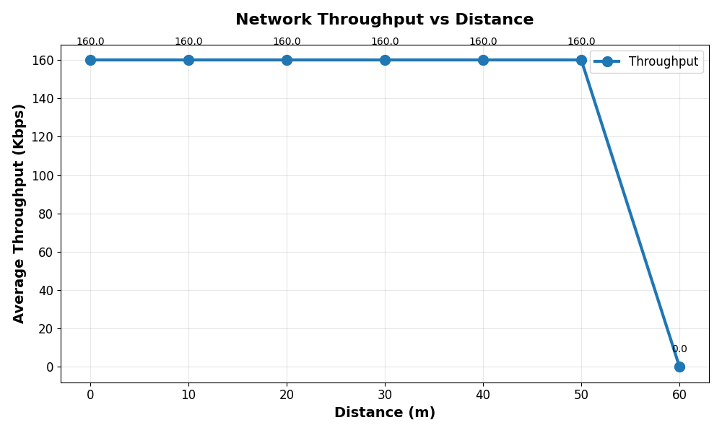

*Figure 7 – Throughput vs Distance (default tx power = 16dBm).*

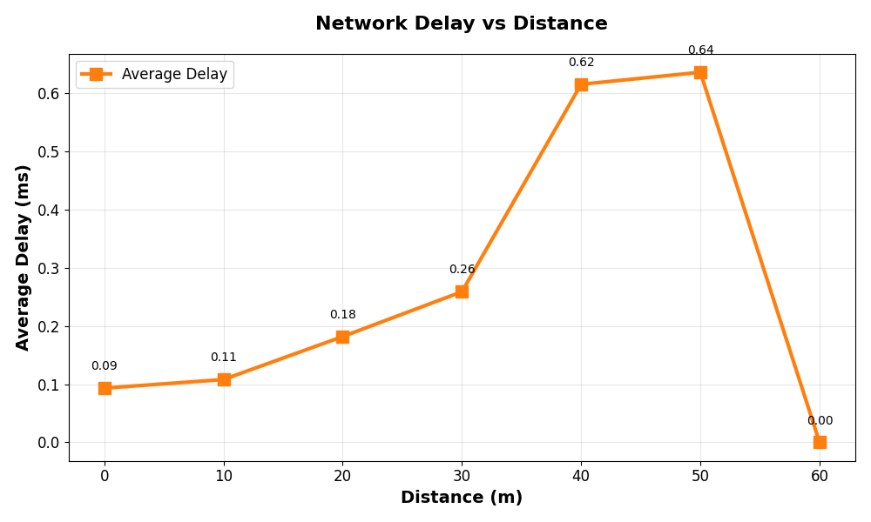

*Figure 8 – Delay vs Distance (default tx power = 16dBm).*

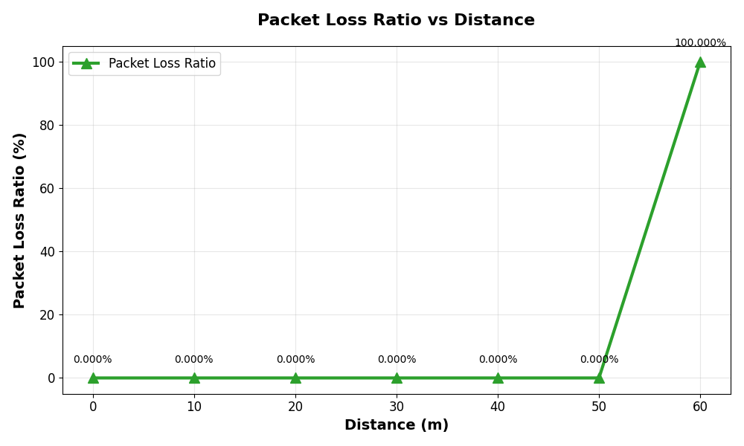

*Figure 9 – PLR vs Distance (default tx power = 16dBm).*

## 2.3 Adjusting Transmission Power

A forum linked [here](https://www.snbforums.com/threads/anyone-using-802-11ax-with-upload-transmit-greater-than-195-230mbps.73848/) was able to help in identifying next steps. To extend the transmission range, the default constructor in the source file was modified to make the transmission power manually adjustable (lines 158-159). The initial power value of 16dBm was increased to 30dBm.

Because dBm is a logarithmic scale, a 14dB increase corresponds to roughly a 25-fold increase in transmitted power. This modification successfully extended the communication range to approximately 150m, as shown in figures 10-12.

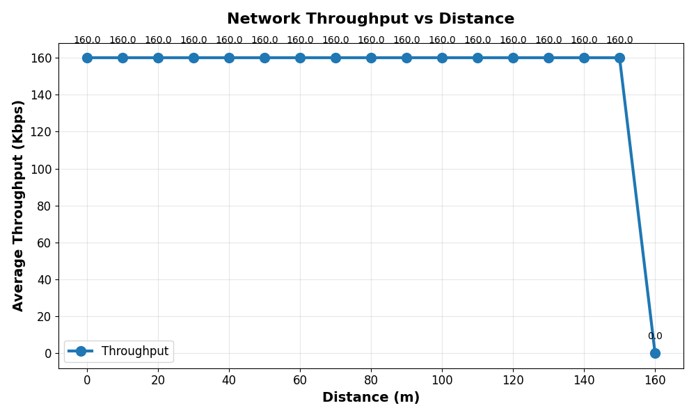

*Figure 10 – Throughput vs Distance (tx power = 30dBm).*

*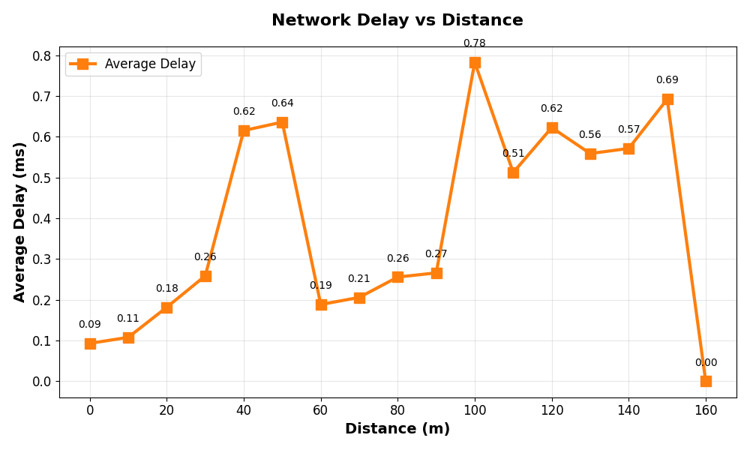 Figure 11 – Delay vs Distance (tx power = 30dBm).*

*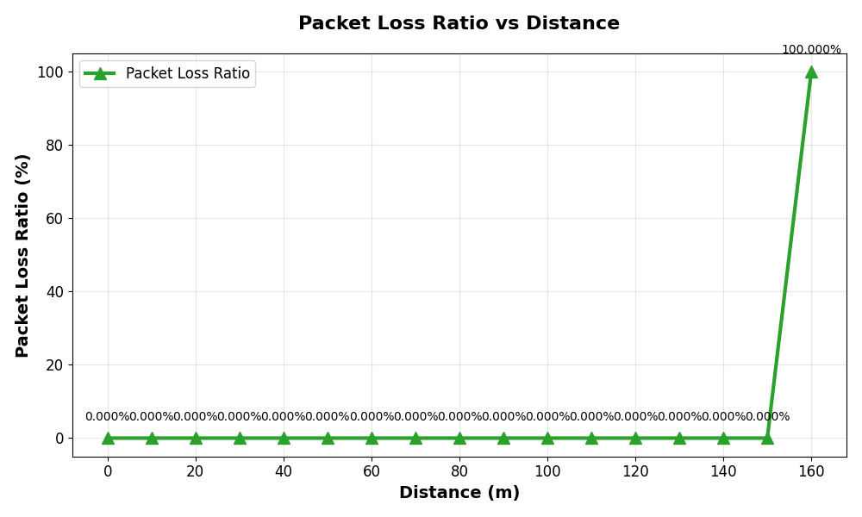 Figure 12 – PLR vs Distance (tx power = 30dBm).*

Although throughput, delay and PLR were measurable up to 150m, further increases in distance again resulted in transmission failure. Therefore, the transmission power was increased once more to 40dBm, allowing stable connectivity for distances up to 200m.

## 2.4 Receiver Sensitivity and Bit Rate Adjustment

At 40dBm, the connection remained stable but unexpectedly exhibited perfect data transmission across all tested distances – throughput remained constant, delay minimal, and PLR ≈ 0%. Such behaviour is unrealistic, since performance should degrade with distance due to signal attenuation and reduced signal-to-noise ratio (SNR).

To introduce realistic performance variation, two further modifications were made:

1. Receiver Sensitivity Adjustment – the sensitivity threshold (line 162) was lowered to make the receiver less tolerant to weak signals, thereby simulating realistic packet reception loss at longer ranges.
2. Bit Rate Increase – based on findings in Question A, the configured bit rate was increased from 160Kpbs to 50Mbps to amplify the impact of distance on these three performance metrics.

These adjustments produce observable changes in throughput, delay, and PLR across the full 0-200m range, creating a valid dataset for further analysis.

## 2.5 Distance vs Throughput

An increase in distance between the user and the AP is expected to cause a decrease in throughput, as signal strength diminishes with range due to path loss and signal attenuation. Consequently, fewer packets are received per unit time.

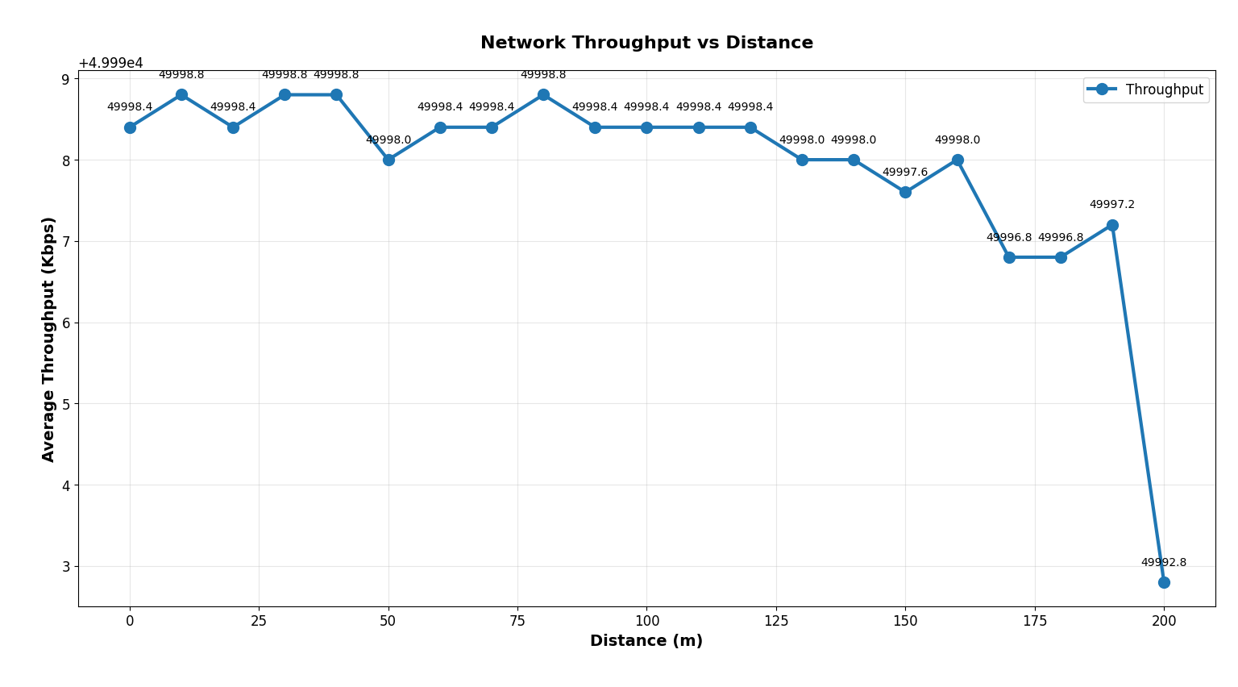

*Figure 13 – Throughput vs Distance (tx power = 40)*

As shown in figure 13, throughput decreases progressively as the distance from the AP increases. While the overall trend follows the expected behaviour, the relationship is non-linear and cannot be easily expressed as a simple proportional function. Minor deviations are observed at specific points, such as 50m and 80m, where throughput briefly drops or rises above the general trend. These fluctuations are attributed to the stochastic nature of wireless channel conditions, including effects such as small-scale fading and random interference.

Overall, the results confirm that increasing distance leads to reduced throughput, consistent with physical layer propagation models and expected attenuation of signal power with range.

## 2.6 Distance vs Delay

As the distance between the user and the AP increases, the average delay is expected to rise, primarily due to increased propagation times.

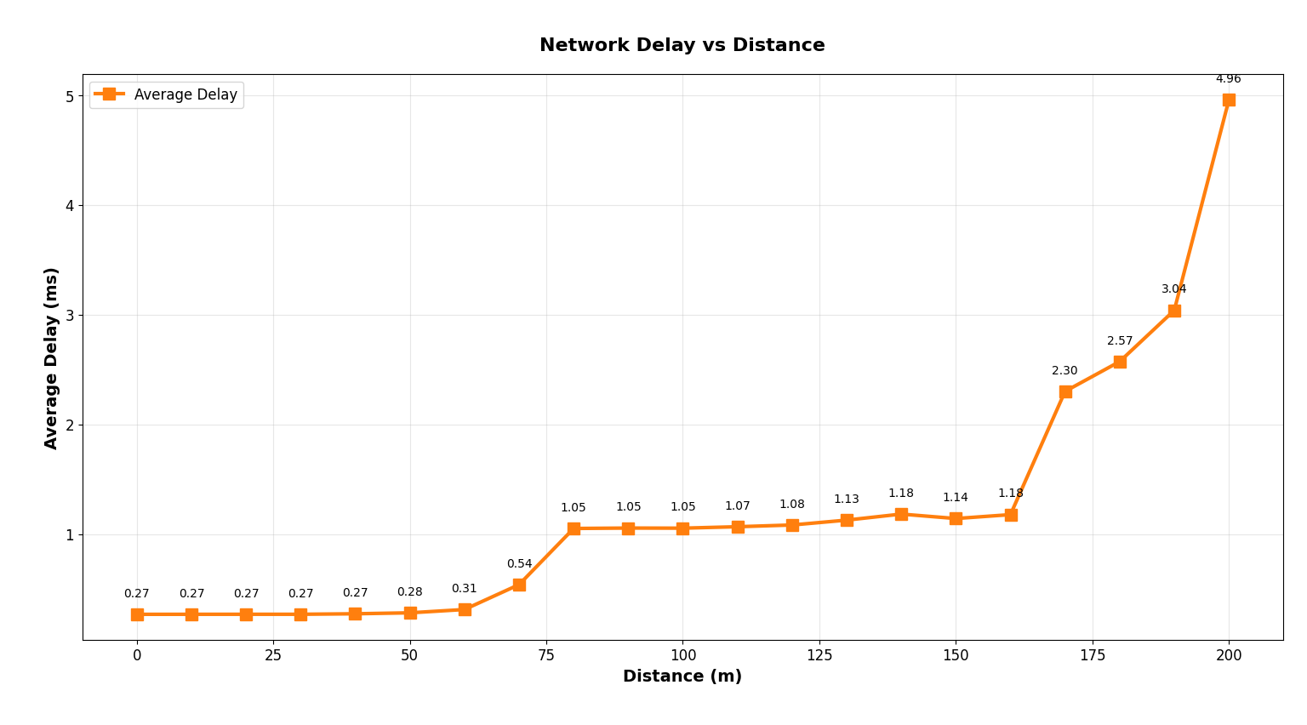

*Figure 14 – Delay vs Distance (tx power = 40)*

Figure 14 illustrates a clear positive correlation between distance and delay. Unlike throughput, the increase in delay with distance is more proportional and predictable. The delay remains relatively low and stable up to approximately 70m, after which a notable rise occurs. A second steep increase is observed beyond 160m, where delay escalates rapidly.

At the maximum distance of 200m, the delay is approximately four times greater than at 160m and nearly double the value of delay at 180m. This sharp increase near the transmission limit reflects edge-of-range behaviour typical of wireless systems, where the SNR drops drastically and retransmissions become more frequent.

These results demonstrate that propagation and queuing delays dominate as the communication range approaches the upper limit of reliable transmission.

## 2.7 Distance vs PLR

Based on the throughput analysis, the PLR is expected to increase with distance, since a weaker signal at longer ranges leads to a higher probability of packet loss or corruption.

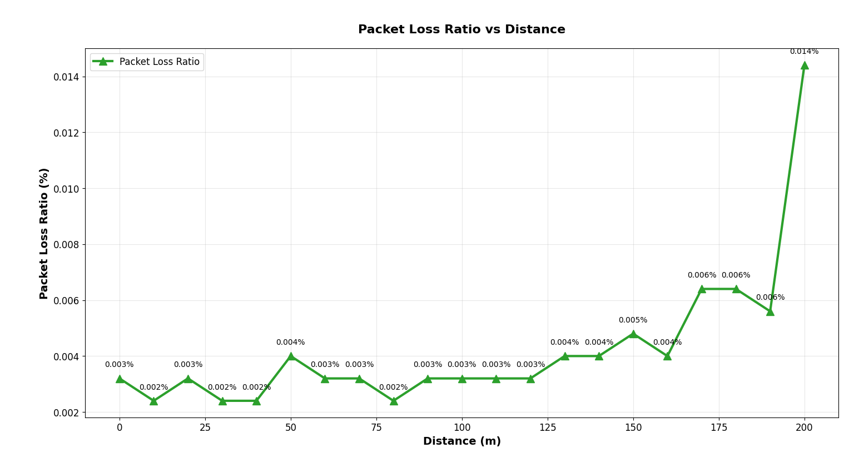

*Figure 15 – PLR vs Distance (tx power = 40)*

Figure 15 confirms this general trend: PLR increases as the user moves further from the AP. However, the rate of increase is non-linear, and several small anomalies are observed. For example, at 50m the PLR (0.004%) is approximately twice that at 40m (0.002%), but this spike does not persist at 60m, suggesting a random transient effect during this simulation. Similarly, a dip at 80m, where PLR is 0.001% lower than at 70m and 90m, represents another stochastic variation.

Despite these local irregularities, the overall PLR rises steadily, reaching its highest value at 200m, which coincides with the lowest throughput and longest delay. This correlation confirms the expected degradation in reliability as distance increases, due to path loss, reduced SNR, and increased transmission failures near the edge of the network’s coverage.

# Question C

## Introduction

The objective of question C is to evaluate the performance of Wi-Fi 6 (802.11ax) and Wi-Fi 7 (802.11be) under varying number of users and different distances from the AP. Wi-Fi 6 was introduced to improve network efficiency in dense environments such as stadiums and transport hubs, offering enhanced spectral utilization through technologies like Orthogonal Frequency Division Multiple Access (OFDMA) and Multi-User Multiple-Input-Multiple-Output (MU-MIMO) [3].

Wi-Fi 7, formally known as IEEE 802.11be Extremely High Throughput (EHT), further extends these capabilities. It has been designed to support emerging high bandwidth and low latency applications including 4K/8K video streaming, virtual reality (VR), augmented reality (AR), and industrial automation [4].

This question combines a review of academic literature with systematic NS-3 simulation results. The literature provides the theoretical basis for understanding the improvements introduced in Wi-Fi 7, while the simulations offer practical comparison using distance-dependent performance metrics across multiple user counts.

## Wi-Fi 6 (IEEE802.11ax)

Wi-Fi 6 was introduced with the objective of improving average per-user throughput by at least four times in densely deployed environments [3]. Operating across the 2.4 GHz and 5 GHz frequency bands, Wi-Fi 6 incorporates several key technologies that enhance spectral efficiency and multi-user performance. These include Orthogonal Frequency Division Multiple Access (OFDMA) for subdividing channels across users, Multi-User Multiple-Input Multiple-Output (MU-MIMO) for supporting simultaneous uplink and downlink communication, and 1024-QAM modulation to increase data density within each transmitted symbol. Wi-Fi 6 supports channel widths up to 160 MHz and can reach peak data rates of up to 10 Gbps. Additional features such as Target Wake Time (TWT) improve energy efficiency by allowing devices to schedule wake intervals for data transmission.

Taken together, these advancements allow Wi-Fi 6 to significantly improve network performance, particularly in scenarios with multiple active users and high-density traffic.

## Wi-Fi 7 (IEEE802.11be)

Wi-Fi 7 extends the capabilities of Wi-Fi 6 by focusing on extremely high throughput and substantially lower latency, enabling support for increasingly demanding applications. The IEEE 802.11be Task Group mandated peak throughputs of at least 30 Gbps and reduced worst-case latency and jitter to ensure reliable performance during real-time communication and immersive media experiences [4].

To meet these requirements, Wi-Fi 7 introduces several architectural enhancements, including support for 320 MHz channel bandwidths, 4096-QAM modulation, and Multi-Link Operation (MLO), which allows devices to transmit concurrently across multiple channels and frequency bands. Additionally, Wi-Fi 7 supports up to 1024 aggregated MAC Protocol Data Units (A-MPDUs), increasing efficiency during high-volume data transfers. These improvements enable Wi-Fi 7 to deliver substantially higher throughput and more stable multi-user performance compared with earlier standards.

## Distance vs Throughput vs User Count

Building on the findings in Question B, it is expected that throughput decreases as distance from the access point increases for both Wi-Fi 6 and Wi-Fi 7. However, the introduction of varying user counts adds an additional dimension to system performance. Increasing the number of users intensifies channel contention and affects resource allocation, meaning that throughput is influenced not only by distance but also by the level of network congestion. In these simulations, the configured bit rate of 5 Mbps per user is significantly lower than the theoretical capabilities of Wi-Fi 6 and Wi-Fi 7, which can reach 9.6 GBPS and up to 46 GBPS, respectively [5]. Nevertheless, the relative performance differences between the standards are still visible even at these reduced data rates.

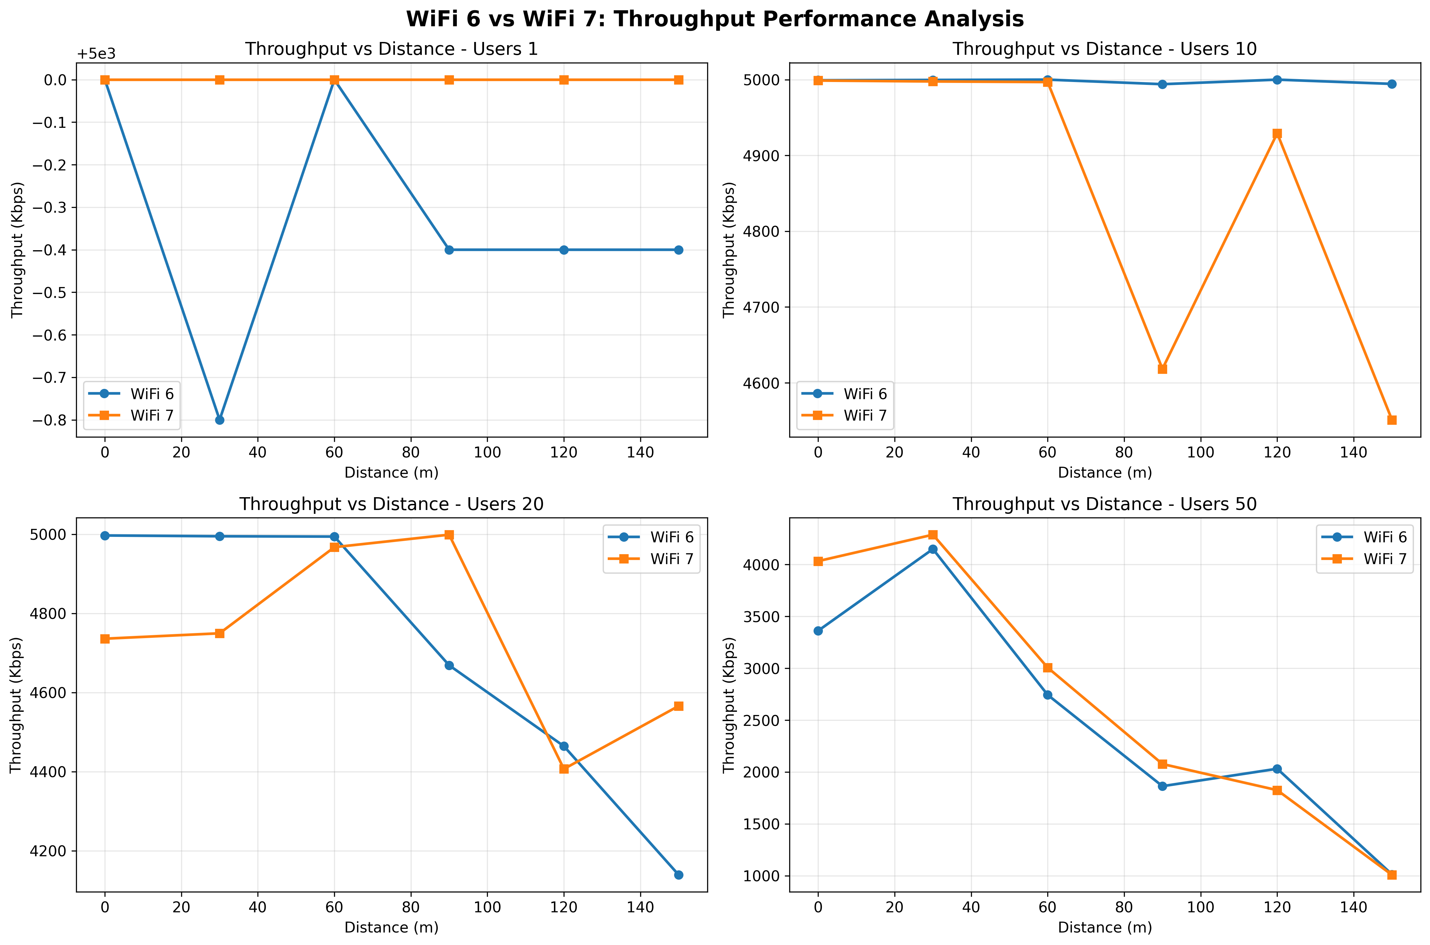

*Figure 16 – Throughput vs Distance for Increasing User Counts*

Figure 16 illustrates the throughput for each user count across the different distances. As expected, throughput declines as distance increases due to signal attenuation and reduced SNR. Throughput also decreases noticeably as user count rises, revealing the impact of channel congestion. Even at 0 metres, the throughput for 50 users is substantially lower than that for 10 users, proving that user load is an influential performance factor independent of distance. Wi-Fi 7 consistently outperforms Wi-Fi 6 for the single user scenario and again for 50 users, reflecting the benefits of its enhanced modulation and multilink capabilities. However, for 10 users, the two standards performed comparably and for 20 users no uniform pattern appears: Wi-Fi 6 performs better at shorter distances, Wi-Fi 7 become superior at intermediate ranges, and performance deviates again at long distances.

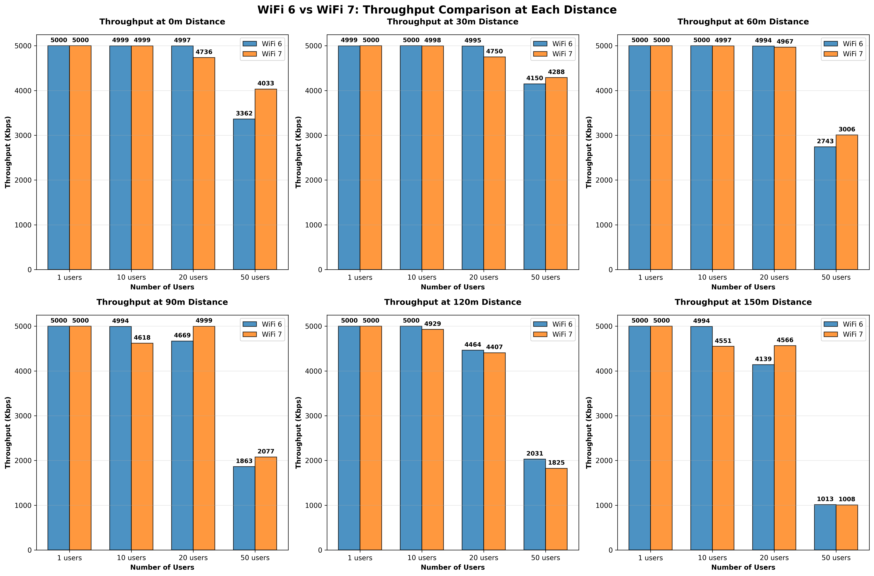

*Figure 17 – A Side-by-Side Comparison of Wi-Fi 6 and Wi-Fi 7’s throughput for different distances from AP for different user counts.*

Figure 17 extends this analysis by presenting throughput for each distance as a separate subplot. Here the influence of user count becomes even clearer, with throughput steadily declining as the number of users increases across all distances. This behaviour stems from 2 main causes: inter symbol interference (ISI) and network congestion. Although OFDMA reduces ISI with orthogonal subcarriers – illustrated by the sync function shown in Figure 18 – interference cannot be eliminated entirely, especially as user density increases. Congestion becomes the dominant factor as the combined demand exceeds available channel capacity, which is reflected in the significantly reduced throughput for 50 users at all distances.

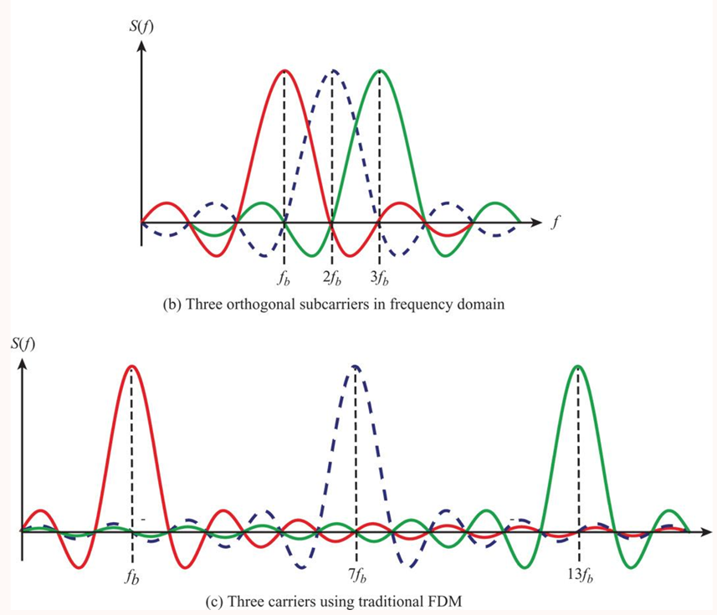

*Figure 18 – Sinc function graphed for OFDM and FDM [6]*

Inter-symbol interference (ISI) occurs when multiple delayed versions of the same symbol overlap at the receiver, causing the received bits to be altered or misinterpreted. Both Wi-Fi 6 and Wi-Fi 7 mitigate ISI by using Orthogonal Frequency Division Multiple Access (OFDMA), which employs orthogonal subcarriers shaped by “sinc” pulses. Because these subcarriers are harmonically related, their spectral peaks occur precisely at the points where the other subcarriers cross zero, ensuring minimal mutual interference. This principle is illustrated in figure 18, where the upper plot shows three orthogonal subcarriers in the frequency domain and highlights how each subcarrier’s peak coincides with the zero-crossings of the others.

Although OFDMA significantly reduces ISI, it does not eliminate all sources of performance degradation. Congestion remains a critical limiting factor, especially as the number of users increases. Congestion arises when the collective bandwidth demand exceeds the channel capacity, resulting in reduced throughput for all users. This behaviour is clearly demonstrated in figure 17, where the throughput for 50 users is substantially lower than for 20 users across every distance tested. The simulations therefore confirm that while OFDMA helps maintain orthogonality among users, high user density still leads to severe contention and diminished performance, particularly in scenarios where many users are active simultaneously.

## Distance vs Delay vs User Count

As the distance between the user and the AP increases, the overall delay exhibited consistent increase. This behaviour is primarily driven by the combined effects of propagation delay, retransmission delay and MAC-layer back off mechanisms. The propagation delay increases linearly with distance because the physical separation between transmitter and receiver dictates the minimum time required for a signal to verse the medium. In isolation, this increase will be small, however, the simulations clearly show that the rise in delay becomes substantially more pronounced once the user moves beyond approximately 120 metres. This indicates that additional delay components beyond simple propagation time become dominant as the signal weakens.

Alongside the increase in distance, increasing the number of users also has a clear impact on delay. This is because as the network becomes more congested, the queuing delay increases as well. This is due to more users trying to communicate with the same node, resulting in more packets entering the buffer and more time before the packet can be processed.

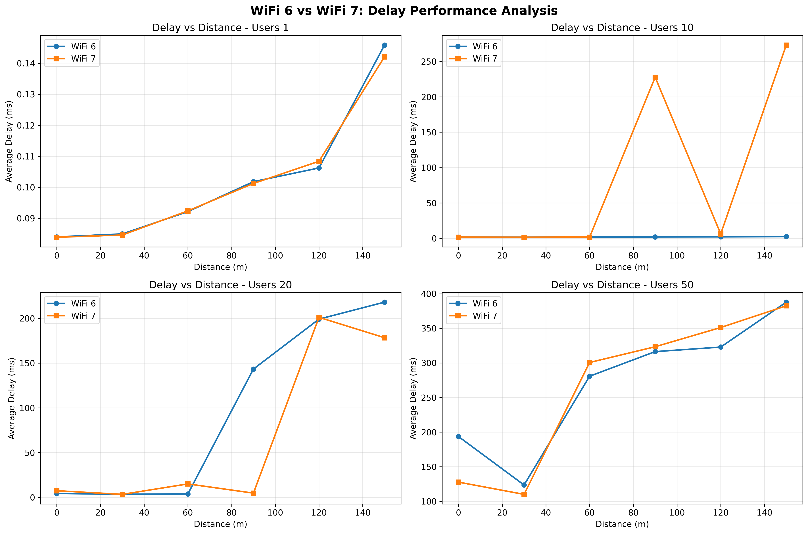

*Figure 19 – Delay vs Distance for increasing number of Users.*

Figure 19 illustrates how delay increases with distance for different user counts and highlights how heavily user density influences overall latency.

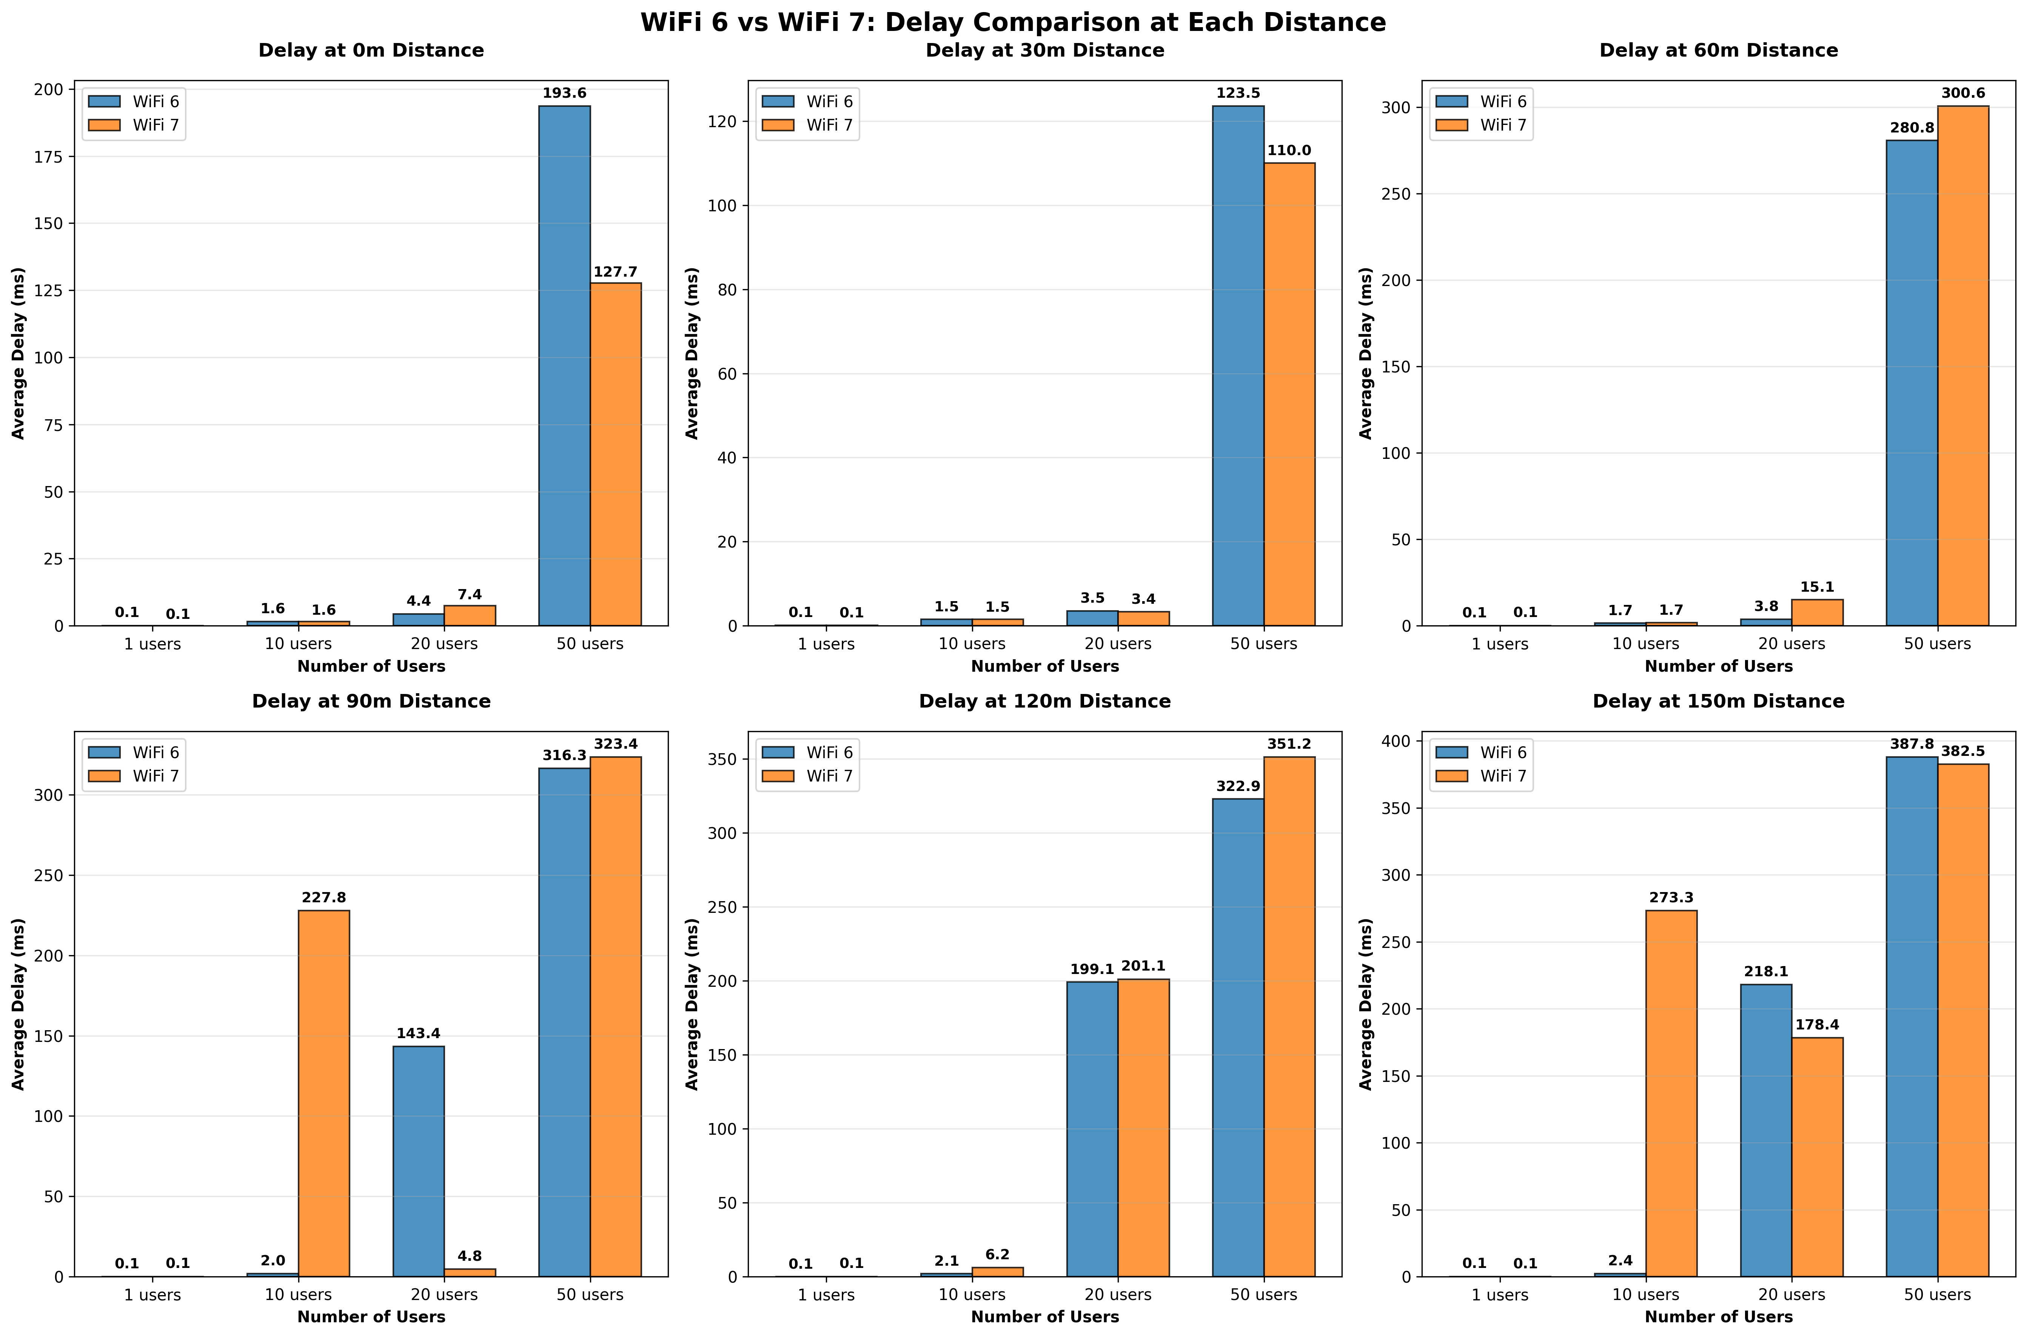

*Figure 20 - A Side-by-Side Comparison of Wi-Fi 6 and Wi-Fi 7’s delay for different distances from AP for different user counts.*

Figure 20 demonstrates how increasing the user count has a direct effect on the delay experienced at the same distance. This side-by-side comparison shows how the two standards perform in relation to each other across all user counts for all distances. The max user count typically skews the y-axis scaling, resulting in some lost granularity at lower user counts but this can be beneficial in terms of evaluating worst-case scenarios.

At smaller distances (0 and 30m) Wi-Fi 7 outperforms Wi-Fi 6 for max users. Their performance is roughly equal outside of this scenario. At higher distances, both standards’ performances deteriorate, with Wi-Fi 7 experiencing the most anomalies across the simulations. This could be due to several factors and simulating these scenarios again would provide more context as to if this is a limitation of Wi-Fi 7 or just random interference exhibited by wireless channels.

## Distance vs PLR vs User Count

In line with both throughput and delay, the PLR increases drastically with increased users and distance. 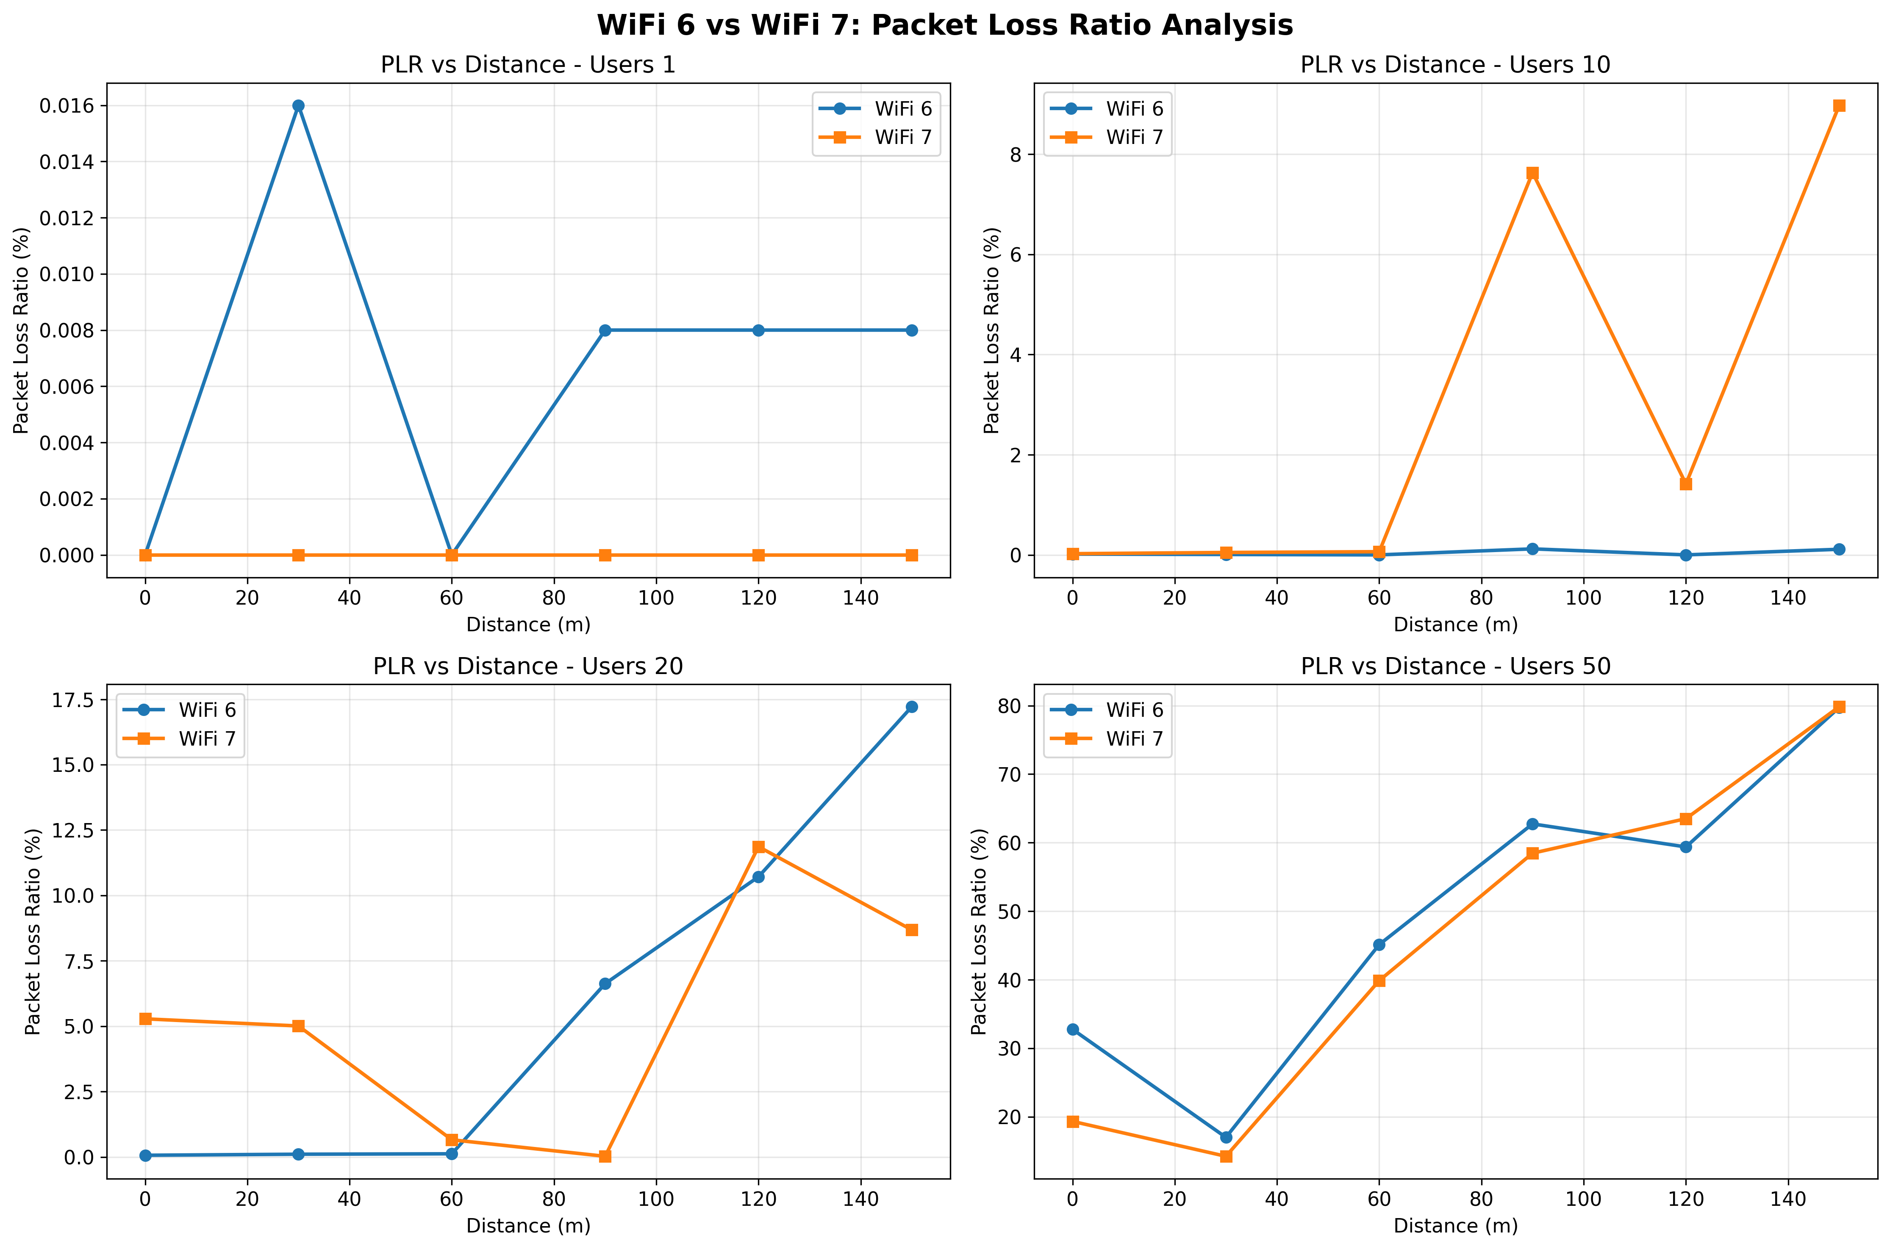

*Figure 21 – PLR vs Distance for increasing number of Users.*

Figure 21 shows the substantial increase in packets lost as the number of users increases. Across all user counts, at small distances (0-30m) the PLR is lowest – this aligns with the observations made in the throughput and delay sections. The increase in PLR lends more information to the increases in delay, most notably the spikes in 10 users for Wi-Fi 7. The PLR here is much higher than would be expected and goes some way to explaining the significant increase in delay.

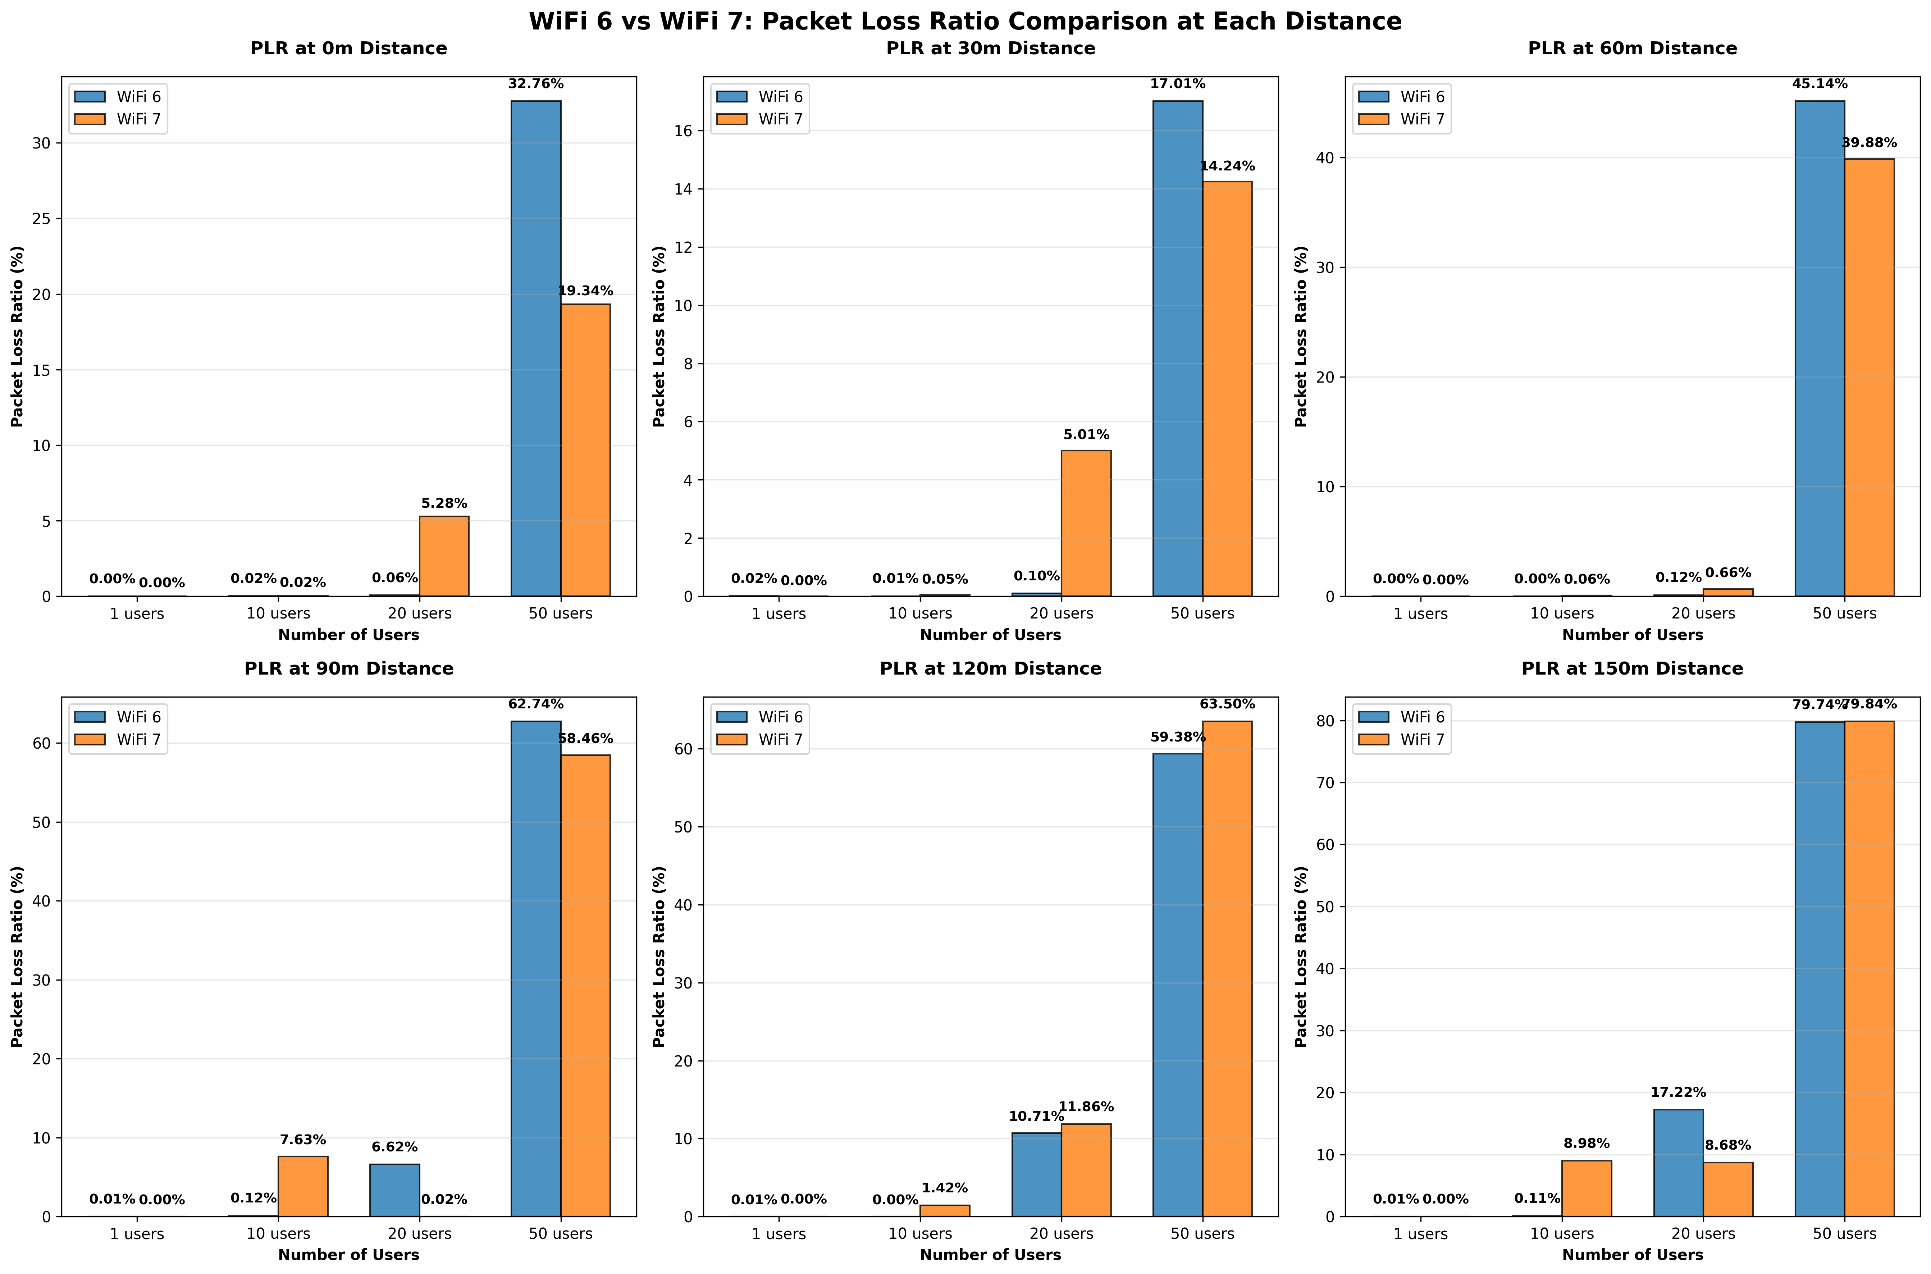

*Figure 22 - A Side-by-Side Comparison of Wi-Fi 6 and Wi-Fi 7’s PLR for different distances from AP for different user counts.*

For both Wi-Fi 6 and Wi-Fi 7, the PLR at 1 user is close to 0%. This aligns with the lack of congestion on the channel. As the number of users increases, both Wi-Fi 6 and Wi-Fi 7 experience a drastic increase in PLR. As the distance increases, the gap between the two standards’ PLR reduces, indicating that at maximum distance, there is no inherent advantage to using one over the other. However, the higher spectral efficiency of Wi-Fi 7 prevails in maximum user PLR. This implies that for more densely populated areas, Wi-Fi 7 would be the best option.

# Comparison and Analysis

## 4.1 Question A

Question A aimed to assess the performance of data transmission in a Wi-Fi network using NS3. Part 1 analysed the system under default conditions (160Kbps), while part 2 explored the impact of varying the configured bit rates (1, 5, 10, 15, 20Mbps). The objective of this comparison is to evaluate how changes in bit rate affect key performance metrics – throughput, delay, and packet loss ratio (PLR) – and to identify general performance trends.

### 4.1.1 Bit Rate vs Throughput

In part 1, the bit rate was calculated by dividing the total transmitted bits by the simulation time, yielding a baseline value of 160Kbps. Under these conditions, the channel exhibited no packet loss and an average delay of 0.000636s, representing ideal performance.

Figure 23 shows the baseline performance metrics, while figure 8 presents results for each configured data rate from part 2. Together, these highlight how increasing bit rate influences throughput and overall performance.

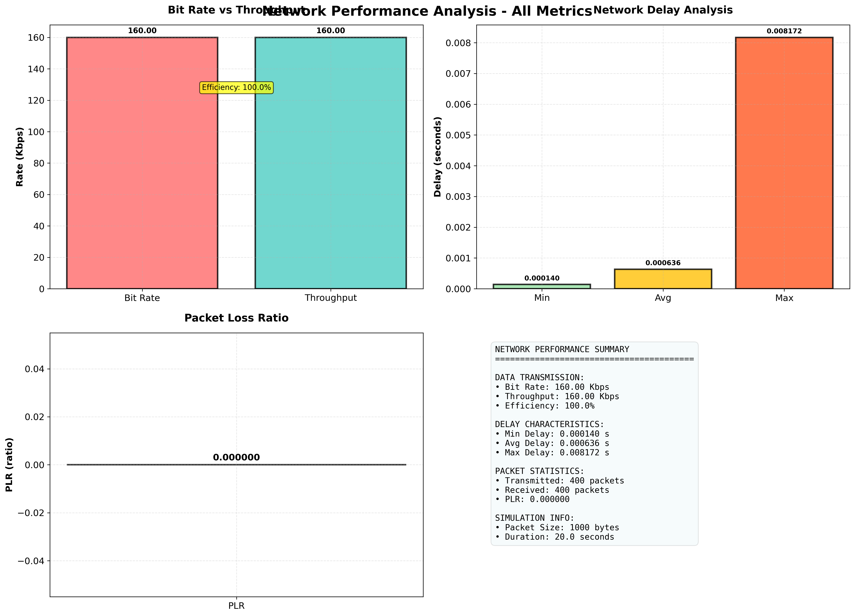

*Figure 23 – Performance statistics for Part 1.*

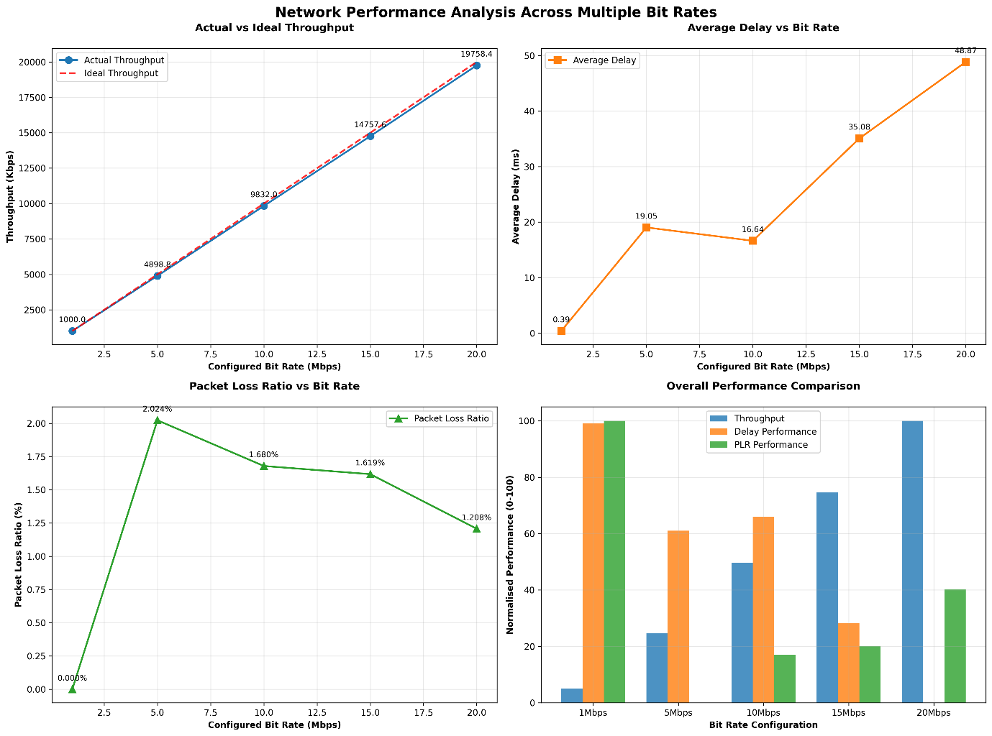

*Figure 24 – Performance statistics for each configured bit rate in part 2.*

At lower bit rates (160Kbps and 1Mbps), throughput and bit rate are nearly identical, implying 100% channel efficiency. As the configured bit rate increases, throughput begins to diverge from the ideal case. This occurs because higher transmission rates introduce greater congestion, buffer saturation, and retransmission events. These factors lead to reduced throughput despite higher nominal data rates.

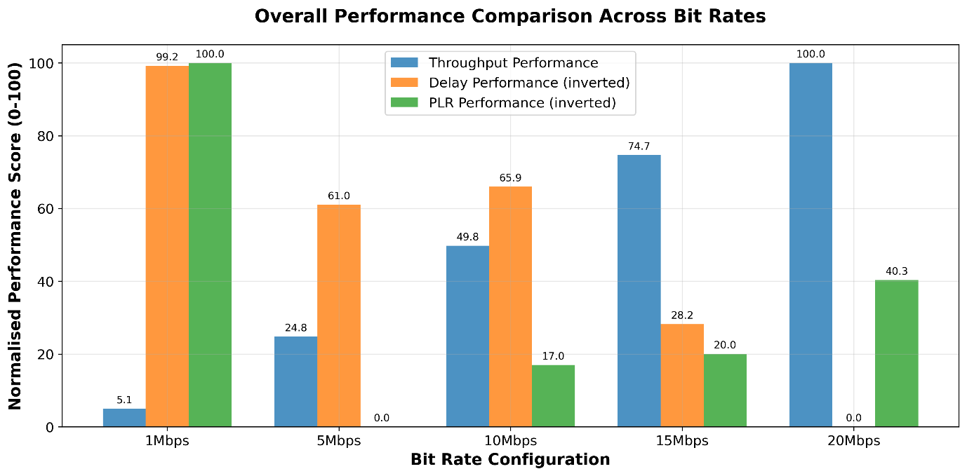

*Figure 25 – Normalised performance comparison across all configured bit rates.*

Figure 25 visualises overall performance across all simulations. Throughput efficiency decreases progressively with increasing bit rate, while PLR and delay both increase. The 1Mbps configuration achieves the highest throughput efficiency, whereas performance at 20Mbps, although normalised to 100% in the plot, represents the least efficient scenario when scaled against configured rate. The anomaly at 5Mbps, where delay deviates unexpectedly, likely reflects the stochastic channel variability inherent in wireless environments rather than systematic simulation error.

In summary, throughput decreases as bit rate increases, confirming the expected inverted relationship between channel load and data delivery efficiency.

### 4.1.2 Bit Rate vs Delay

In part 1, the average delay was 0.000636 seconds, which increased as the configured bit rate rose, as shown in figure 5. This trend aligns with queuing theory – as more packets are injected into the network per second, node buffers experience higher occupancy, leading to longer queuing and processing times.

Although the relationship between bit rate and delay is generally proportional, the results exhibit an irregularity at 5Mbps, where the delay is greater than the subsequent value. This behaviour is attributed to random channel variation rather than deterministic factors, demonstrating NS3’s capability to model the stochastic nature of wireless communication.

In this simulation, several parameters were held constant – distance, transmission speed, bandwidth, and packet size – ensuring that observed variations in delay were primarily due to changes in bit rate. This provides a clear relationship between increased data rate and delay accumulation.

Delay is a critical metric for communicating systems requiring real-time performance. In practical terms, adaptive protocols (e.g. TCP) often reduce bit rate dynamically to maintain acceptable delay when network conditions degrade. Hence, while higher bit rates may seem advantageous, they can lead to increased latency and reduced quality of experience under congested conditions.

### 4.1.3 Bit Rate vs PLR

In part 1, the PLR was 0%, consistent with the ideal throughput observed at 160Kbps. As the bit rate increased in part 2, PLR generally rose but not in a strictly linear or predictable manner. Figure 6 illustrates that the PLR reached its highest value at 5Mbps, supporting the conclusion that this simulation experienced transient congestion or buffer overflow.

Interestingly, between 10Mbps and 20Mbps, the PLR slightly decreased (≈0.4%), suggesting that packet loss behaviour in wireless channels is influenced by random environmental and queuing factors rather than solely by transmission rate. Although one might expect PLR to rise steadily with increased bit rate, this result underscores the non-linear and stochastic nature of the simulated channel.

Furthermore, while the percentage of packet loss provides a useful measure of reliability, the absolute number of lost packets also increases with higher bit rates because more packets are transmitted overall. For instance, a 1% PLR at 15Mbps represents a greater volume of dropped packets than the same ratio at 10Mbps, potentially affecting user experience, despite similar percentages.

### 4.1.4 Overall Trends

Across both parts, a consistent pattern emerges:

* Throughput decreases as bit rate increases, indicating reduced efficiency at higher transmission rates.
* Delay increases approximately proportionally to bit rate, consistent with queuing and congestion effects
* PLR exhibits a non-linear increase, demonstrating random packet loss behaviour within the simulated wireless channel.

These trends collectively show that performance is optimal at lower bit rates, where packet delivery is stable, delay is minimal, and efficiency approaches 100%. As bit rate rises, the network becomes less efficient due to increased congestion and retransmission overhead.

It should be noted that this simulation involved only two nodes (sender and receiver) with fixed parameters, excluding intermediate routing nodes or interference sources. While this simplification helps isolate the effect of bit rate, it limits the realism of the results. Future simulations incorporating more complex technologies or mobility models would provide a more comprehensive view of real-world network performance.

## 4.2 Question B

Question B aimed to assess the performance of data transmission in a Wi-Fi 6 (IEEE 802.11ax) network by varying the distance between the access point (AP) and the user, while maintaining a fixed bit rate. The analysis provides insight into how distance impacts the key performance metrics under controlled simulation conditions.

The nominal transmission rate used in these simulations was 50 Mbps, whereas Wi-Fi 6 is theoretically capable of achieving up to 9.6 Gbps. At higher bit rates, the observed performance degradations would likely be more pronounced, but the overall trends identified here remain representative of real-world behaviour.

### 4.2.1 Distance vs Throughput

Throughput consistently decreased as the transmission distance increased, reflecting the expected impact of signal attenuation over range. At shorter distances (below 50m), throughput remained close to the configured rate, indicating minimal path loss and nearly ideal channel conditions. As the separation exceeded 50m, throughput declined, marking the transition from a strong-signal region to a marginal one.

This reduction in throughput at longer distances is primarily caused by a decrease in the signal-to-noise ratio (SNR) – the ratio of signal power to noise power in the channel. A higher SNR indicates clearer transmission and fewer corrupted packets, while a lower SNR increases the probability of bit errors and retransmissions. Each retransmission consumes bandwidth without contributing to new data delivery, thus reducing overall throughput.

The lack of a perfectly smooth decline in throughput further confirms the stochastic nature of wireless channels, where small-scale fading, interference, and random noise cause performance variations even under static simulation conditions.

### 4.2.2 Distance vs Delay

Delay exhibited a clear positive correlation with distance. Up to approximately 70m, both propagation and processing delays remained minimal, but beyond this range, average delay increased steadily. The most substantial delay growth occurred after 160m, where the network approached its maximum effective transmission range.

This trend reflects both propagation delay, which increases with physical distance, and queuing delay, which rises when retransmissions occur as SNR deteriorates. The sharp increase in delay beyond 160m signifies the network entering a high-latency region, where repeated transmission attempts are required before successful packet delivery.

Although the overall drop in throughput beyond this range was not extreme (for example, over 10%), the trend is theoretically consistent with real-world Wi-Fi behaviour near the edge of coverage zones. It should be noted that using a fixed rate of 50 Mbps may have limited the degree of observable delay variation; a higher bit rate would likely produce more pronounced latency effects.

### 4.2.3 Distance vs PLR

The PLR results followed a similar trend to throughput and delay. Packet loss increased with distance, confirming that data reliability declines as the received signal weakens. PLR remained minimal up to approximately 170m, but began rising sharply thereafter, peaking at 200m – the limit of effective communication for this configuration.

Localised anomalies were observed at 50m and 80m, where small deviations from the overall trend occurred. These are typical of random channel effects within NS3’s wireless propagation model and do not indicate simulation error. The simultaneous increase in PLR and delay, along with reduced throughput near 200 m, strongly supports the conclusion that the system was operating near its maximum reliable range.

### 4.2.4 Overall Trends

The combined results illustrate a correlated degradation across all three metrics:

* As distance increases, throughput decreases.
* As throughput decreases, delay and PLR increase.
* The onset of significant performance degradation occurs beyond approximately 160m, marking the edge of reliable communication for the simulated configuration.

These findings align with established path loss and propagation models, which predict an exponential decay in received power as distance increases. While Wi-Fi 6 can theoretically achieve bit rates up to 9.6 Gbps, its practical coverage range is typically limited to 30-120 m depending on indoor or outdoor conditions [2].

As distance increases, the number of retransmissions and corrupted packets grows, resulting in lower effective throughput and increased delay and PLR. Although the simulation used a lower bit rate (50 Mbps), the underlying relationships remain valid and would be more pronounced at higher rates or under multi-user conditions typical of modern Wi-Fi 6 networks.

## 4.3 Question C

### 4.3.1 Literature

Wi-Fi 7 aims to deliver a maximum throughput of 30Gbps by combining features like 4K-QAM, 320MHz bandwidth, 1024 MPDU aggregation, and multi-link support. In contrast, Wi-Fi 6 was introduced with a top speed of 10Gbps. Wi-Fi 7 leverages a significantly wider bandwidth, reaching 320MHz by aggregating spectrum across the 2.4GHz and 5GHz bands, effectively doubling the maximum nominal throughput achieved by Wi-Fi 6. Furthermore, Wi-Fi 7 uses a higher-order modulation scheme, 4096-QAM, compared to Wi-Fi 6’s 1024-QAM. This upgrade in modulation increases the nominal rate by 20% compared to 1024-QAM [4]. However, this increase in modulation complexity introduces the possibility of increased errors as the distances between the mappings is greatly reduced. Wi-Fi 7 also enhances data transmission efficiency by increasing the maximum number of MPDUs aggregated per A-MPDU to 1024, far exceeding the 256 MPDU aggregation often used as a baseline for Wi-Fi 6 [4].

Wi-Fi 7 introduces Multi-Link Operations (MLO), a crucial feature that allows devices to transmit and receive data over multiple radio interfaces across the 2.4GHz and 5GHz bands, simplifying dynamic link switching and packet reassembly [4]. Simulations show that MLO significantly improves latency, reducing delay by approximately 30% compared to Wi-Fi 6 when operating with two 160MHz links [4]. Although both standards utilise OFDMA to improve spectrum efficiency and allow multiple users to share channel resources, Wi-Fi 7 further optimises this by supporting the assignment of Multiple Resource Units (MRU) per station. In comparison, Wi-Fi 6 typically restricts the AP to allocating only a Single RU (SRU) to each station, which can decrease throughput when few stations are present [4]. Both standards employ the Target Wake Time (TWT) to support MLO scenarios.

### 4.3.2 Throughput vs Distance vs User Count

For a single user, the throughput of both Wi-Fi 6 and Wi-Fi 7 is pretty much optimal. Wi-Fi 6 experiences a brief dip at 30 metres, just below the 5Kbps nominal right. However, this is marginal and it returns to 100% efficiency for 60m before dropping slightly again for the remainder of the distances. This is expected due to there only being a single user so there is no risk of collision or congestion – especially because of the reduced data rate.

For 10 users, Wi-Fi 7 has a dip from its nominal data rate at 90 metres and again at 150 metres, these are the two sharpest declines in throughput that have been observed for this simulation. Wi-Fi 6 also has a marginal deviation from its nominal rate at 90 metres, but not to the same extent as Wi-Fi 7. Wi-Fi 7 is also dipping at 120 metres, but not to the same extent as the distances preceding and succeeding it. These are all expected characteristics of throughput with respect to distance and a user input of 10. It is likely that the dip at 90 metres is exaggerated due to random variance within the channel, rather than a limitation of the standard, as if the dip was to mirror that of Wi-Fi 6, the decrease in throughput with respect to distance for 10 users for Wi-Fi 7 would be much more linear. Despite Wi-Fi 7’s better spectral efficiency for 10 users, it would be recommended to use Wi-Fi 6 based on this simulation.

When the simulation was run for 20 users, the decrease in throughput for Wi-Fi 6 with respect to distance is far more linear than that of Wi-Fi 7. While Wi-Fi 7 starts off with a lower throughput at 0 metres than Wi-Fi 6, it steadily increases up to 90 metres, where then it decreases rapidly at 120 metres and rebounds at 150. This goes to show the stochastic nature of wireless transmission, and further simulations would provide a more characteristic trend of Wi-Fi 7 for 20 users rather than this simulation. Wi-Fi 6’s sharp decline after 60 metres implies that it would be unsuitable for ranges greater than 60 metres for 20 users based on this simulation. The trends shown by Wi-Fi 6 here would imply that it is not catering to increased congestion on the channel at greater distances.

At 50 users, Wi-Fi 7 outperforms Wi-Fi 6 at all distances apart from 120 metres. Both standards experienced the same pattern in the graph, however, Wi-Fi 6 is consistently underperforming apart from at the aforementioned distance. This is likely due to a random increase in Wi-Fi 6’s efficiency, rather than representative of its overall characteristics based on the decline observed at 20 users.

Overall, it's difficult to categorise Wi-Fi 6 or Wi-Fi 7 as the better standard as both prevail in this simulation in different areas. For minimal users, Wi-Fi 7 appears to be the best solution as it has the best spectral efficiency of the two standards. However, it is noted at 20 users, there is random variation in the throughput for Wi-Fi 7 and this should be considered when choosing which standard to implement. From more congested areas, it is likely that Wi-Fi 7 would perform better than Wi-Fi 6 based on the trends noted in the graph relating to a user count of 50.

### 4.3.3 Delay vs Distance vs User Count

For a single user, delay increases proportionally with distance, and both Wi-Fi 6 and Wi-Fi 7 exhibit nearly identical performance. This behaviour is expected because, with only one active user, contention is minimal, and the delay is dominated primarily by propagation time and small variations in SNR as distance increases.

When the user count is increased to 10, the plotted delay appears to remain at 0 milliseconds for most distances. This does not imply that the delay is actually 0, but rather the values were extremely small relative to the axis scaling. The spikes observed at 90 metres and at 150 metres for Wi-Fi 7, indicate that the finer granularity of the fractional millisecond values is being visually compressed. These isolated spikes are likely caused by stochastic variations in the channel, and their lack of repetition across adjacent distances suggests that they are not representative of the general trend. Wi-Fi 6 appears to perform more consistently than Wi-Fi 7 at 10 users, but this impression is largely due to the vertical scale of the Y axis, which compresses small variations. A more meaningful comparison would require isolating distances such as 0, 30 and 60 metres, where both standards show minimal anomalies, and separately analysing Wi-Fi 7’s deviations at 90 and 150 metres in order to determine whether they stem from random variation or from a systematic difference in behaviour between the two standards.

For 20 users, a clear trend emerges: Wi-Fi 7 generally outperforms Wi-Fi 6 across most distances, with the difference becoming especially pronounced beyond 60 metres. Wi-Fi 6 exhibits a sharp increase in delay between 60 and 90 metres, and this elevated delay persists as distance continues to increase. Wi-Fi 7 also displays a steep increase between 90 and 120 metres but then stabilises before rising again at 150 metres. These trends align closely with throughput results for the same distances and user counts. As the network becomes more congested and SNR decreases with distance, retransmissions and MAC-layer back off become more frequent, leading to significant increases in delay. It is also noteworthy that for 20 users, delay often reaches the hundreds of milliseconds range - a stark contrast to the fractional millisecond delays observed in the single user case.

For 50 users, the behaviour becomes even more dependent on both distance and the standard used. At short distances, Wi-Fi 7 clearly outperforms Wi-Fi 6, most notably at 0 and 30 metres, where it's additional bandwidth and multilink capabilities allow it to manage contention more effectively. However, from 60 metres onwards, Wi-Fi 7 begins to show consistently higher delay than Wi-Fi 6, and this pattern continues until 150 m. At this maximum simulated distance, Wi-Fi 6 ultimately performs worse than Wi-Fi 7, reflecting the point at which Wi-Fi 6 reaches its operational limits sooner due to lower spectral efficiency and reduced robustness at long range.

Overall, the presence of anomalies in the 10-user case makes it difficult to draw strong conclusions about whether Wi-Fi 7 consistently outperforms Wi-Fi 6 in terms of delay at low to moderate levels of users. However, the most consistent performance advantage appears when the user count is 20, where Wi-Fi 7 outperformed Wi-Fi 6 by a substantial margin across most distances. This suggests that Wi-Fi 7’s delay advantages become more meaningful as network load increases, which aligns with its design goal of supporting high density, high traffic environments.

### 4.3.4 PLR vs Distance vs User Count

For single user, Wi-Fi 7 consistently outperforms Wi-Fi 6 across all distances. Wi-Fi 7 maintains a PLR of 0% throughout the entire simulation, while Wi-Fi 6 exhibits more packet loss – most notably beyond 90 metres where the PLR remains constant for the remaining distances. An anomaly also appears at 30 metres for Wi-Fi 6, but because this behaviour does not persist at 60 metres or beyond, it is likely attributable to random channel fluctuations rather than a fundamental weakness of the standard. These results align with expectations as a single-user scenario benefits from minimal contention, allowing Wi-Fi 7’s enhanced modulation and coding capabilities to operate effectively.

For 10 users, Wi-Fi 6 consistently outperforms Wi-Fi 7. In this case, the PLR values are an order of magnitude larger than in the single-user scenario, and the axis scaling compresses the differences at short distances, specifically between 0 and 60 metres, making direct visual comparison more difficult. This mirrors the limitation discussed in this delay analysis where granularity was lost in the short distance range due to very small underlying values. The sharp increase in packet loss for Wi-Fi 7 at 90 metres correlates directly with the anomalous delays observed in the corresponding delay analysis. From 90 metres onwards, Wi-Fi 7 consistently experiences higher packet loss than Wi-Fi 6. Although this behaviour suggests the Wi-Fi 7 is more vulnerable than Wi-Fi 6 to packet corruption under moderate user load in the simulation, a single run cannot establish this as a definitive characteristic of the standard. A large number of iterations would be required to verify whether this is a reproducible trend or stochastic artefact.

At 20 users, Wi-Fi 7 experiences more irregular packet loss behaviour compared to Wi-Fi 6. Wi-Fi 6 exhibits a nearly linear increase in PLR once the distance exceeds 60 metres, reflecting a predictable deterioration of link quality under increasing path loss and congestion. Wi-Fi 7, however, shows a non-monotonic trend: its PLR decreases between 0 and 90 metres, then spikes sharply at 120 metres and subsequently falls again at 150 metres. This behaviour lacks a clear pattern and suggests the Wi-Fi 7’s more aggressive spectral utilisation introduces greater sensitivity to channel variations in mid-range distances. Interestingly, Wi-Fi 7’s delay remains relatively low even when the packet loss increases, indicating that its higher spectral efficiency allows it to retransmit corrupted packets more effectively. This suggests that PLR alone does not fully capture the experienced performance and that higher order mechanisms within the MAC and physical layers help mitigate the impact of lost packets.

For 50 users, Wi-Fi 7 consistently outperforms Wi-Fi 6 up to 120 metres. At this distance, Wi-Fi 6 briefly shows a lower PLR than Wi-Fi 7, but this value deviates from the trend seen at neighbouring distances and can therefore be treated as an anomaly. Both standards exhibit the same general pattern of increasing packet loss with increasing distance when user count is high. The fact that Wi-Fi 7’s value at 120 metres is consistent with both the preceding and subsequent distances indicates stable behaviour, whereas the isolated dip for Wi-Fi 6 suggests a momentary gain in efficiency caused by channel randomness rather than an inherent advantage of the standard. By 150 metres, Wi-Fi 6 once again performs worse than Wi-Fi 7, reaffirming the broader trend that Wi-Fi 7 scales more effectively under heavy congestion and at long distances.

### 4.3.5 Overall Trends with respect to the Literature

The overall trends observed in this simulation broadly align with key performance claims found in the literature regarding Wi-Fi 6 and Wi-Fi 7, while also revealing several deviations that can be attributed to the simulation configuration and inherent limitations of the modelling environment. The literature consistently highlights Wi-Fi 7's superior technology, offering higher throughput, lower latency, and improved efficiency due to enhancements such as 4K-QAM modulation, 320MHz channel bandwidth, increased MPDU aggregation, MLO, and more flexible OFDMA resource unit allocation. These features collectively aim to deliver up to 30 Gbps throughput, improve resilience under congestion, and reduce worst case delay by approximately 30% when using multiple links. The expectation, therefore, is that Wi-Fi 7 will outperform Wi-Fi 6 across most performance metrics, particularly as user density or channel demands increase.

The simulation results support these expectations under high user loads. When 50 users are active, Wi-Fi 7 consistently delivers higher throughput, lower delay and reduced packet loss across almost all instances compared with Wi-Fi 6. This behaviour matches the literature's assertion that Wi-Fi 7 is designed for high efficiency operation in congestion environments, with its wider bandwidth and advanced modulation offering a clear advantage. Similarly, in the 20-user scenario, Wi-Fi 7 provides noticeably lower delay than Wi-Fi 6 across most instances, reaffirming the claim that its architectural improvements enable more efficient handling of channel contention and retransmissions. These findings align closely with the studies, indicating that features like MLO and larger MPDU aggregation improved Wi-Fi 7’s performance under load by enabling faster data recovery and more flexible resource allocation.

However, several deviations from the literature were also observed. At 10 users, Wi-Fi 6 often outperforms Wi-Fi 7 in throughput, delay, and PLR, which appears inconsistent with claims that Wi-Fi 7 should provide superior performance even under moderate user density. These discrepancies are likely due to relatively low bit rate used (5Mbps) in the simulation, which does not fully exploit Wi-Fi 7’s capabilities. Under such a constrained bit rate, the benefits of features like 4K-QAM, 320MHz channels, or large aggregation windows do not materialise because the simulated traffic does not require them. The irregular behaviour observed for Wi-Fi 7 at 20 users, including non-monotonic PLR changes and unstable throughput, can therefore be attributed to a combination of random channel variations and the use of single run simulations without statistical averaging.

These deviations highlight important considerations when comparing simulation findings with theoretical expectations. Wi-Fi 7’s benefits are most pronounced in scenarios involving high data rates, multi-Gigabit bandwidth and dense user environments – conditions under which its enhanced modulation and multilink capabilities can operate effectively. The simulation presented here operates far below these real-world rates, meaning that some of Wi-Fi 7’s advantages remain dormant. Likewise, without repeated trials or confidence intervals, isolated anomalies such as the spikes at 90 metres and 150 metres for 10 users cannot be fully distinguished from stochastic wireless behaviour. Nevertheless, when congestion increases substantially, as seen with 50 users, the performance gap between these two standards widens, exactly as the literature suggests, underscoring the scalability improvements inherent to Wi-Fi 7.

Overall, when interpreted alongside the literature, the simulation results demonstrate that Wi-Fi 7’s theoretical strengths, particularly in high density environments, are reflected in practice, even within the constraints of the modelling setup. Although some moderate load and mid-distance behaviours diverge from expectations, these discrepancies can be explained by the modelling limitations and the low bit rate used. The broader trend remains clear: Wi-Fi 7 offers superior performance when the network becomes congested or when users demand higher efficiency, aligning strongly with the architectural enhancements documented in the literature.

# 5. References

[1] arvindpdmn, “5G UE Data Rate,” *Devopedia*, Feb. 04, 2021. <https://devopedia.org/5g-ue-data-rate>

[2] “Wi-Fi 6,” *Wikipedia*, Feb. 02, 2022. https://en.wikipedia.org/wiki/Wi-Fi_6

‌[3] R. G. Rathor and R. D. Joshi, “Performance Analysis of IEEE802.11ax (Wi-Fi 6) Technology using Multi-user MIMO and Up-Link OFDMA for Dense Environment,” *IEEE Xplore*, Nov. 01, 2021. <https://ieeexplore.ieee.org/abstract/document/9708544/>

[4] X. Liu, Y. Dong, Y. Li, Y. Lin, X. Yang, and M. Gan, “IEEE 802.11be Wi-Fi 7: Feature Summary and Performance Evaluation,” *arXiv.org*, 2023. <https://arxiv.org/abs/2309.15951>

[5] S. Jangsher, Lecture Notes for EEN1043 – Mobile/Wireless Communications, <https://loop.dcu.ie/pluginfile.php/6433402/mod_resource/content/1/WLAN.pdf>

[6] S. Jangsher, Lecture Notes for EEN1043 – Mobile/Wireless Communications, <https://loop.dcu.ie/pluginfile.php/6354289/mod_resource/content/1/Multiplexing%20_OFDM.pdf>

6. Appendix A – Files

## 6.1 Question A

All files for Question A were moved into the folder “QuestionA” to ensure the correct files were being used. For this question the file path is “~***Assignment/QuestionA/<filename>” where *** denotes the path to the folder Assignment.

### 6.1.1 Part 1

DataOfUser1-1759407075-default-.sca

### 6.1.2 Part 2

DataOfUser1-1759410141-1000kbps-.sca

DataOfUser1-1759410152-5000kbps-.sca

DataOfUser1-1759410158-10000kbps-.sca

DataOfUser1-1759410167-15000kbps-.sca

DataOfUser1-1759410177-20000kbps-.sca

## 6.2 Question B

### 6.2.1 Original Sim

All the files listed here are stored in the folder “QuestionB-Original-Sim”. This is to ensure the correct files were used and the file pathing is the same as mentioned for Question A. DataOfUser1-1759412866-0m-.sca

DataOfUser1-1759413106-10m-.sca

DataOfUser1-1759413111-20m-.sca

DataOfUser1-1759413115-30m-.sca

DataOfUser1-1759413119-40m-.sca

DataOfUser1-1759407075-default-.sca

DataOfUser1-1759414176-60m-.sca # File before tx power change

DataOfUser1-1759415401-60m-.sca

DataOfUser1-1759415506-70m-.sca

DataOfUser1-1759415511-80m-.sca

DataOfUser1-1759415513-90m-.sca

DataOfUser1-1759415516-100m-.sca

DataOfUser1-1759415689-110m-.sca

DataOfUser1-1759415691-120m-.sca

DataOfUser1-1759415693-130m-.sca

DataOfUser1-1759415695-140m-.sca

DataOfUser1-1759415697-150m-.sca

DataOfUser1-1759415701-160m-.sca # File before second tx power change

DataOfUser1-1759416980-160m-.sca

DataOfUser1-1759416985-170m-.sca

DataOfUser1-1759416988-180m-.sca

DataOfUser1-1759417049-190m-.sca

DataOfUser1-1759417053-200m-.sca

### 6.2.2 Altered Sim

All the files here are stored in the folder “QuestionB-Altered-Sim”.

DataOfUser1--50000kbps-0m-.sca

DataOfUser1--50000kbps-10m-.sca

DataOfUser1--50000kbps-20m-.sca

DataOfUser1--50000kbps-30m-.sca

DataOfUser1--50000kbps-40m-.sca

DataOfUser1--50000kbps-.sca

DataOfUser1--50000kbps-60m-.sca

DataOfUser1--50000kbps-70m-.sca

DataOfUser1--50000kbps-80m-.sca

DataOfUser1--50000kbps-90m-.sca

DataOfUser1--50000kbps-100m-.sca

DataOfUser1--50000kbps-110m-.sca

DataOfUser1--50000kbps-120m-.sca

DataOfUser1--50000kbps-130m-.sca

DataOfUser1--50000kbps-140m-.sca

DataOfUser1--50000kbps-150m-.sca

DataOfUser1--50000kbps-160m-.sca

DataOfUser1--50000kbps-170m-.sca

DataOfUser1--50000kbps-180m-.sca

DataOfUser1--50000kbps-190m-.sca

DataOfUser1--50000kbps-200m-.sca

## 6.3 Question C

### 6.3.1Wi-Fi 6

All the files listed here are stored in the folder “QuestionC/Wifi6”. This is to ensure the correct files were used and the file pathing is the same as mentioned for Question A.

DataOfUser1-run-1763041112-0m-1users-WiFi6_80211ax-run-1763041112.sca

DataOfUser1-run-1763041112-0m-10users-WiFi6_80211ax-run-1763041112.sca

DataOfUser1-run-1763041112-0m-20users-WiFi6_80211ax-run-1763041112.sca

DataOfUser1-run-1763041112-0m-50users-WiFi6_80211ax-run-1763041112.sca

DataOfUser1-run-1763041112-30m-1users-WiFi6_80211ax-run-1763041112.sca

DataOfUser1-run-1763041112-30m-10users-WiFi6_80211ax-run-1763041112.sca

DataOfUser1-run-1763041112-30m-20users-WiFi6_80211ax-run-1763041112.sca

DataOfUser1-run-1763041112-30m-50users-WiFi6_80211ax-run-1763041112.sca

DataOfUser1-run-1763041112-60m-1users-WiFi6_80211ax-run-1763041112.sca

DataOfUser1-run-1763041112-60m-10users-WiFi6_80211ax-run-1763041112.sca

DataOfUser1-run-1763041112-60m-20users-WiFi6_80211ax-run-1763041112.sca

DataOfUser1-run-1763041112-60m-50users-WiFi6_80211ax-run-1763041112.sca

DataOfUser1-run-1763041112-90m-1users-WiFi6_80211ax-run-1763041112.sca

DataOfUser1-run-1763041112-90m-10users-WiFi6_80211ax-run-1763041112.sca

DataOfUser1-run-1763041112-90m-20users-WiFi6_80211ax-run-1763041112.sca

DataOfUser1-run-1763041112-90m-50users-WiFi6_80211ax-run-1763041112.sca

DataOfUser1-run-1763041112-120m-1users-WiFi6_80211ax-run-1763041112.sca

DataOfUser1-run-1763041112-120m-10users-WiFi6_80211ax-run-1763041112.sca

DataOfUser1-run-1763041112-120m-20users-WiFi6_80211ax-run-1763041112.sca

DataOfUser1-run-1763041112-120m-50users-WiFi6_80211ax-run-1763041112.sca

DataOfUser1-run-1763041112-150m-1users-WiFi6_80211ax-run-1763041112.sca

DataOfUser1-run-1763041112-150m-10users-WiFi6_80211ax-run-1763041112.sca

DataOfUser1-run-1763041112-150m-20users-WiFi6_80211ax-run-1763041112.sca

DataOfUser1-run-1763041112-150m-50users-WiFi6_80211ax-run-1763041112.sca

### 6.3.2 Wi-Fi 7

All the files listed here are stored in the folder “QuestionC/Wifi7”. This is to ensure the correct files were used and the file pathing is the same as mentioned for Question A.

DataOfUser1-run-1763041112-0m-1users-WiFi7_80211be-run-1763041112.sca

DataOfUser1-run-1763041112-0m-10users-WiFi7_80211be-run-1763041112.sca

DataOfUser1-run-1763041112-0m-20users-WiFi7_80211be-run-1763041112.sca

DataOfUser1-run-1763041112-0m-50users-WiFi7_80211be-run-1763041112.sca

DataOfUser1-run-1763041112-30m-1users-WiFi7_80211be-run-1763041112.sca

DataOfUser1-run-1763041112-30m-10users-WiFi7_80211be-run-1763041112.sca

DataOfUser1-run-1763041112-30m-20users-WiFi7_80211be-run-1763041112.sca

DataOfUser1-run-1763041112-30m-50users-WiFi7_80211be-run-1763041112.sca

DataOfUser1-run-1763041112-60m-1users-WiFi7_80211be-run-1763041112.sca

DataOfUser1-run-1763041112-60m-10users-WiFi7_80211be-run-1763041112.sca

DataOfUser1-run-1763041112-60m-20users-WiFi7_80211be-run-1763041112.sca

DataOfUser1-run-1763041112-60m-50users-WiFi7_80211be-run-1763041112.sca

DataOfUser1-run-1763041112-90m-1users-WiFi7_80211be-run-1763041112.sca

DataOfUser1-run-1763041112-90m-10users-WiFi7_80211be-run-1763041112.sca

DataOfUser1-run-1763041112-90m-20users-WiFi7_80211be-run-1763041112.sca

DataOfUser1-run-1763041112-90m-50users-WiFi7_80211be-run-1763041112.sca

DataOfUser1-run-1763041112-120m-1users-WiFi7_80211be-run-1763041112.sca

DataOfUser1-run-1763041112-120m-10users-WiFi7_80211be-run-1763041112.sca

DataOfUser1-run-1763041112-120m-20users-WiFi7_80211be-run-1763041112.sca

DataOfUser1-run-1763041112-120m-50users-WiFi7_80211be-run-1763041112.sca

DataOfUser1-run-1763041112-150m-1users-WiFi7_80211be-run-1763041112.sca

DataOfUser1-run-1763041112-150m-10users-WiFi7_80211be-run-1763041112.sca

DataOfUser1-run-1763041112-150m-20users-WiFi7_80211be-run-1763041112.sca

DataOfUser1-run-1763041112-150m-50users-WiFi7_80211be-run-1763041112.sca

# 7. Appendix B – Images

## 7.1 Question A

All images for this section have been saved in the folder “QuestionA” and the image names are listed in the order they appear in the document.

### 7.1.1 Part 1

#### 7.1.1.1 “QuestionA-Part1-BitRate-Throughput.png”

#### 7.1.1.2 “QuestionA-Part1-BitRate-Delay.png”

#### 7.1.1.3 “QuestionA-Part1-BitRate-PLR.png”

### 7.1.2 Part 2

#### 7.1.2.1 “QuestionA-Part2- Throughput.png”

#### 7.1.2.1 “QuestionA-Part2-Delay.png”

#### 7.1.2.1 “QuestionA-Part2-PLR.png”

## 7.2 Question B

### 7.2.1 Original Sim

All figures here are stored in the folder “QuestionB-Original-Sim” and are listed in order that they appear in the document

#### 7.2.1.1 “Issues-with-greater-than-50m-throughput.png”

#### 7.2.1.2 “Issues-with-greater-than-50m-delay.png”

#### 7.2.1.3 “Issues-with-greater-than-50m-plr.png”

#### 7.2.1.4 “Issues-with-greater-than-150m-throughput.png”

#### 7.2.1.5 “Issues-with-greater-than-150m-delay.png”

#### 7.2.1.6 “Issues-with-greater-than-150m-plr.png”

### 7.2.2 Altered Sim

All figures here are stored in the folder “QuestionB-Altered-Sim” and are listed in order that they appear in the document. Within this folder there are many other images that were not used in the report. They have not been deleted as they led to design decisions – such as using 50Mbps rather than 5Mbps. They are included in the submission for if the corrector wants to view but are not required to gain a better understanding of the document presented

#### 7.2.2.1 “Throughput-50Mbps.png”

#### 7.2.2.2 “Delay-50Mbps.png”

#### 7.2.2.3 “PLR-50Mbps.png”

## 7.3 Question C

All the files listed here are stored in the folder “QuestionC”. They are listed in the same order as they appear in the document.

#### 7.3.1 “QuestionC-Throughput-Analysis-WiFi6-vs-WiFi7.png”

#### 7.3.2 “QuestionC-SideBySide-Throughput-Comparison.png”

#### 7.3.3 “OFDM-Sinc-Explanation.png”

#### 7.3.4 “QuestionC-Delay-Analysis-WiFi6-vs-WiFi7.png”

#### 7.3.5 “QuestionC-SideBySide-Delay-Comparison.png”

#### 7.3.6 “QuestionC-PLR-Analysis-WiFi6-vs-WiFi7.png”

#### 7.3.7 “QuestionC-SideBySide-PLR-Comparison.png”

## 7.4 Comparison

### 7.4.1 Question A

#### 7.4.1.1 “QuestionA-Part1-CombinedMetrics.png”

#### 7.4.1.2 “QuestionA-Part2-Combined.png”

#### 7.4.1.3 “QuestionA-Part2-Performance.png”